Subhabrata Ganguli

Control System Design with an Industrial Perspective:

With MATLAB Examples

Table of Contents

Acknowledgement 2

Introduction 3

1 PID Control Implementation 9

1.1 Overview 9

1.2 Implementation of PI Controller 10

1.2.1 Setpoint Weights 12

1.2.2 Implementation of the Integral Term 14

1.2.2.1 Anti-windup mechanism 1: Limiting the min/max value of the integrator state 16

1.2.2.2 Anti-windup mechanism 2: Disabling PI control integrator during plant input saturation 17

1.2.2.3 Anti-windup mechanism 3: Implementing of anti-windup filter 18

1.3 Implementation of a PID controller 20

1.3.1 Implementation of the Derivative Term. 20

1.3.2 Usage of derivative term for a PID controller 21

1.3.3 Lead Compensator 23

1.4 Position and Velocity Control Using Acceleration Input 27

3 Dynamic Inversion Controller 29

3.1 Introduction 29

3.2 Dynamic inversion controller design 29

4 Model Predictive Controller 32

2 F-16 Model and Simulations 36

3.1 Equations of Motion 36

3.2 MATLAB/Simulink Model – Trim and Linearization 39

3.3 Pitch Rate Control for Longitudinal Dynamics 47

3.4 Roll, Pitch and Yaw Rate Control 51

Appendix A 58

Appendix B 60

References 93

Dedicated to:

My parents, my wife Ankur and my children Diya and Aditya

# Acknowledgement

Writing this book has been a rewarding journey, and I would not have been able to complete it without the support of many people.

First and foremost, I want to express my deepest gratitude to my wife, Ankur, my children, Diya and Aditya and my parents. Their unwavering love, patience, and understanding during the long hours spent writing and editing were invaluable. Their constant encouragement kept me motivated throughout this project.

I am also grateful to my editor, [Editor Name], for their invaluable guidance and expertise. Their insightful feedback and meticulous editing significantly improved the clarity and accuracy of the book.

I extend my thanks to the reviewers, [Reviewer Name 1] and [Reviewer Name 2], for their thorough review and constructive criticism. Their suggestions helped me refine the content and ensure the book meets the needs of its audience.

A special thank you goes to my colleagues Prof. Raktim Bhattacharya [Colleague Name 2], for their insightful discussions and technical support. Their willingness to share their knowledge and experience was instrumental in shaping the content of this book.

Finally, I am thankful to my friends and family for their unwavering support and encouragement throughout this process.

# Introduction

"Control Design and Applications with an Industrial Perspective" offers a comprehensive exploration of control engineering principles and their practical applications in industrial settings. This book bridges the gap between theoretical concepts and real-world implementation, providing readers with a deep understanding of control system design and its significance in industrial processes and automation.

In today's dynamic and competitive industrial landscape, effective control design plays a critical role in enhancing productivity, ensuring product quality, and optimizing resource utilization. From manufacturing plants to chemical processing facilities, from power generation to automotive production lines, aerospace systems, precise and reliable control systems are essential for achieving operational efficiency and maintaining competitiveness.

This book is designed to serve as a valuable resource for engineers, researchers, and students seeking to grasp the fundamental principles of control design and apply them in industrial contexts. It covers a wide range of topics, including classical and modern control techniques, system modeling and identification, controller synthesis and tuning, and advanced control strategies such as adaptive control, robust control, and model predictive control.

Key Features:

* Provides an overview of control engineering fundamentals, with an emphasis on industrial applications.
* Offers practical insights and real-world examples drawn from various industrial sectors, illustrating the relevance and impact of control design in diverse settings.
* Includes case studies and simulations to facilitate practical implementation.

Whether you are a seasoned control engineer looking to expand your knowledge base or a student aspiring to enter the field of industrial automation, "Control Design and Applications with an Industrial Perspective" equips you with the essential tools and insights needed to tackle complex control challenges and drive innovation in industrial processes.

The book has two parts. Part 1 is called *Control Design and Analysis*. The first part provides an overview of some of the control methods used in industry. It contains chapters on proportional-integral-derivative (PID) controller, model predictive controller (MPC) and dynamic inversion controller.

Proportional-Integral-Derivative (PID) control is indeed one of the most ubiquitous and versatile feedback control mechanisms employed extensively in industrial processes. It adjusts the control input (e.g., aero-control surfaces, steering position, valve position, motor speed, etc.) based on the difference between the desired setpoint and the actual process variable. PID control can be applied to a wide range of industrial processes due to its ability to be fine-tuned by adjusting the proportional, integral, and derivative gains (Kp, Ki, Kd). **By** combining these three control actions, PID controllers can achieve good response times, minimize steady-state errors, and enhance system stability. The concept behind PID control is relatively straightforward, making it easy to understand and implement.

MPC is an advanced control strategy that utilizes a dynamic model of the process to predict its future behavior and optimize control actions over a finite time horizon. It considers constraints on the control inputs, process variables, and disturbances. MPC uses a mathematical model of the process dynamics to predict how the process variables will evolve over time in response to control inputs. At each time step, MPC solves an optimization problem to find the control inputs that minimize a cost function, subject to process constraints and desired performance criteria. MPC can handle complex multivariable systems, account for constraints, and adapt to changes in process dynamics or setpoints.

Dynamic inversion is a control technique used for nonlinear systems. It involves designing a controller that cancels out the nonlinearities of the system, effectively transforming it into a linear system that can be controlled using standard linear control techniques. The dynamic inversion controller is designed based on a dynamic model of the system. It includes terms that counteract the nonlinear effects, making the system appear linear.

Dynamic inversion controllers can be robust to changes in operating conditions and disturbances, as long as the system remains within the bounds of validity of the linearized model. Dynamic inversion may not be suitable for highly nonlinear systems or systems with uncertain dynamics, as accurate modeling of nonlinearities is crucial for its effectiveness.Dynamic inversion finds applications in aerospace, robotics, and other domains where accurate control of nonlinear systems is required.

Each of these control methods has its strengths and weaknesses, and the choice depends on factors such as the nature of the process, performance requirements, and available resources.

Join us on a journey to explore the intricate world of control engineering and discover how it shapes the future of industrial automation.

Part 1:

Control Design and Analysis

In this part of the book, we will concentrate on Linear Time Invariant (LTI) plant which does not have any modeling uncertainty. Our goal is to gain insight into some of the key aspect of control design in a simplistic setup.

We will look into a simple but fundamental plant model called a *double integrator*. This type of plant appears in various industrial problems. One of them is related to velocity and position control of Adaptive Cruise Control (ACC) system in automotive vehicles. In ACC, velocity control is required to maintain a set speed during normal operations. In traffic, the vehicle may not be able to operate at the set speed and may need to drive at a lower speed by maintaining a fixed distance from the lead traffic vehicle.

We will use various control design techniques to obtain position and velocity tracking. We will start with a classical control method called Proportional-Integral-Derivative (PID) control. We will also show how a Lead Compensation can be used as an alternate technique. Finally, we will delve into various control analysis techniques to check the stability and tracking performance of the closed-loop system.

# PID Control Implementation

## Overview

PID control, which stands for Proportional-Integral-Derivative control, is a widely used feedback control mechanism in engineering and industrial applications.

PID Control is a type of closed-loop control system that continuously calculates an error value as the difference between a desired setpoint and a measured process variable. The PID controller then adjusts the control input to the system based on three main components: proportional, integral, and derivative terms.

Here is a brief overview of the different components of the PID controller:

**1. Proportional (P) Term**:

* The proportional term is directly proportional to the current error. It contributes to the control output in proportion to the magnitude of the error.
* The goal of the proportional term is to reduce the steady-state error, which is the difference between the desired setpoint and the actual process variable when the system has stabilized.

**2. Integral (I) Term**:

* The integral term is proportional to both the magnitude and the duration of the error. It accumulates the error over time.
* The integral term helps eliminate any residual steady-state error that may be present after the proportional control has brought the system close to the setpoint.

3. **Derivative (D) Term:**

* The derivative term is proportional to the rate of change of the error. It anticipates future behavior based on the current rate of change of the error.
* The derivative term helps to dampen the system's response, preventing overshooting and oscillations.

The overall control output (u) of the PID controller is calculated as the sum of the three terms:

$u\left(t\right)=K_{p}.e\left(t\right)+K_{I}.\int_{0}^{t}{e\left(τ\right)dτ}+K_{D}.\frac{de(t)}{dt}$,

where *u*(*t*) and *e*(*t*) are the control and error signals, and *KP*, *KI* and *K­D* are the PID gains.

## Implementation of PI Controller

Note that although all the above terms on the right-hand side of the equation uses the error term *e*(*t*) as the feedback signal, it is not an ideal approach to implement the controller as such. Using the error term in the closed-loop system adds a zero in the transfer function between the controlled signal and the reference signal which can cause an unnecessary fast response in the beginning and can even cause an overshoot. Hence, an idea called *setpoint weights* is typically used in the actual implementation.

Let us try understanding the problem of implementation of a PI controller with an illustrative example. Consider a first order plant:

$$\frac{Y}{U}=\frac{b}{s+a}.$$

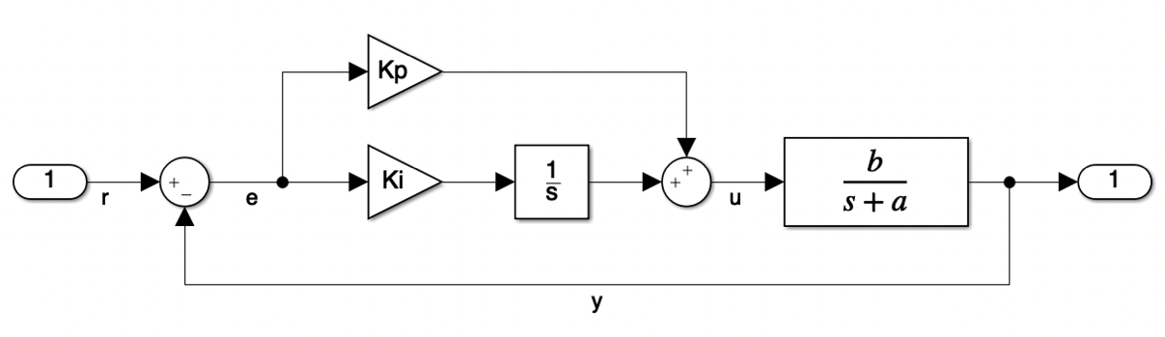

Figure 1: Closed-loop system with PI controller.

The closed-loop system with the PI controller is shown in Figure 1. The closed-loop transfer function is given by:

$$\frac{\left(K_{P}+\frac{K_{I}}{s}\right)\left(\frac{b}{s+a}\right)}{1+ \left(K_{P}+\frac{K_{I}}{s}\right)\left(\frac{b}{s+a}\right)}, \\ =\frac{K_{P}bs+K_{I}b}{s^{2}+\left(a+K_{P}b\right)s+K_{I}b}.$$

Thus, we see that the closed-loop transfer function has a zero at $-\frac{K_{I}b}{K_{p}b}=-\frac{K_{I}}{K_{p}}$. If we want the closed-loop system to behave like a second order system with a corner frequency of $ω$ and damping ratio of $ζ$, then we can write:

$$\frac{K_{P}bs+K_{I}b}{s^{2}+\left(a+K_{P}b\right)s+K_{I}b}=\frac{ks+ω^{2}}{s^{2}+2ζωs+ω^{2}}.$$

Equating the coefficients of *s* in the denominator, we have:

|  |  |
| --- | --- |
| $$K_{P}=\frac{2ζω-a}{b},$$ | (1) |
| $$K_{I}=\frac{ω^{2}}{b}.$$ | (2) |

Let us consider a specific example with $a=1, b=20, ω=4$ rad/sec and $ζ=1$. Using equations (1) and ((*2*), the PI gains can be calculated as *KP* = 0.35 and *KI* = 0.8. The implementation in Simulink is shown in Figure 2. If we look at the step response in Figure 3, we see that it has an overshoot before the output settles down to one. This is due the presence of a zero of $-\frac{0.8}{0.35}$ rad/sec $=-2.3$ rad/sec in the transfer function of the closed-loop system.

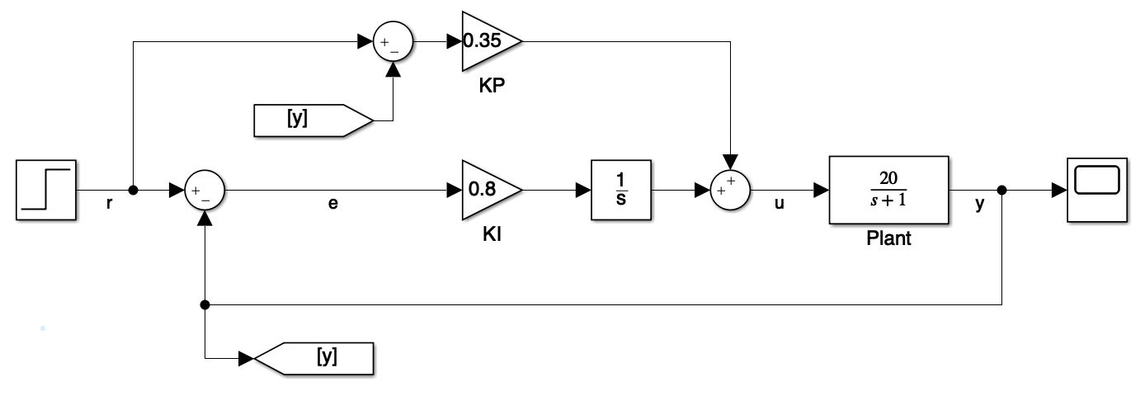

Figure 2: PI Controller with error term as feedback for both K­P and K­­I.

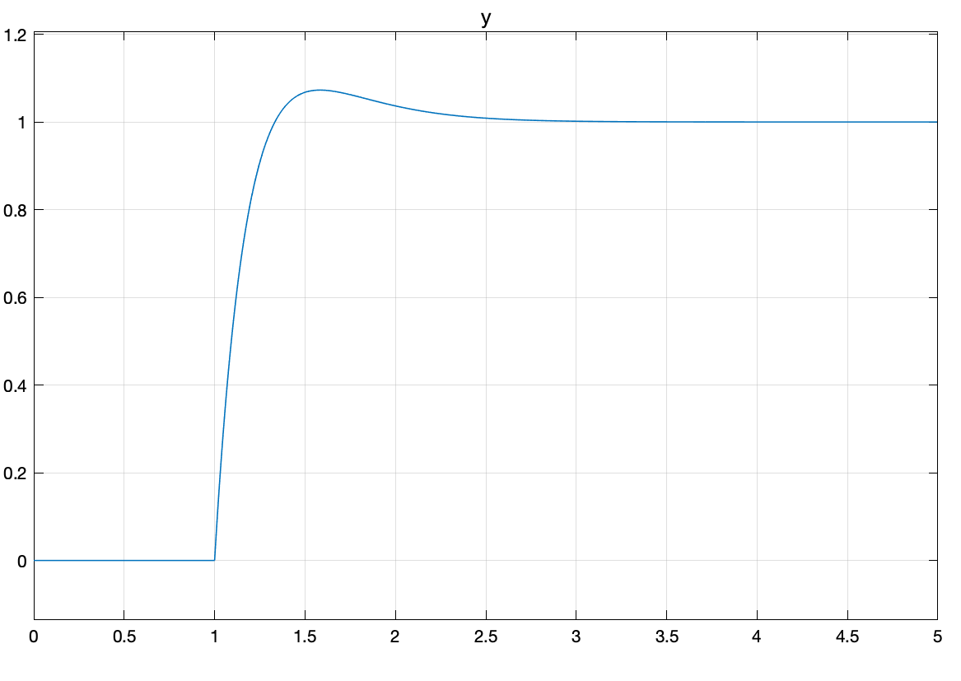

Figure 3: Step response of closed-loop for PI controller with error signal feedback for both K­P and K­­I. (Time in x-axis is in sec).

### Setpoint Weights

A better way to implement a PID controller is to weight the set-point/reference signal. We scale the proportional term feedback as $αr\left(t\right)-y(t)$ and derivative term feedback as $βr\left(t\right)-y(t)$ where *r*(*t*) and *y*(*t*) are the reference and the feedback signals respectively and $α$ and $β$ are positive scalars. These scalars terms are designer’s choices. The Simulink implementation for our PI controller example is shown in Figure 4. For example, if we set $α=0$ in our PI controller example, we get no overshoot as shown in Figure 5.

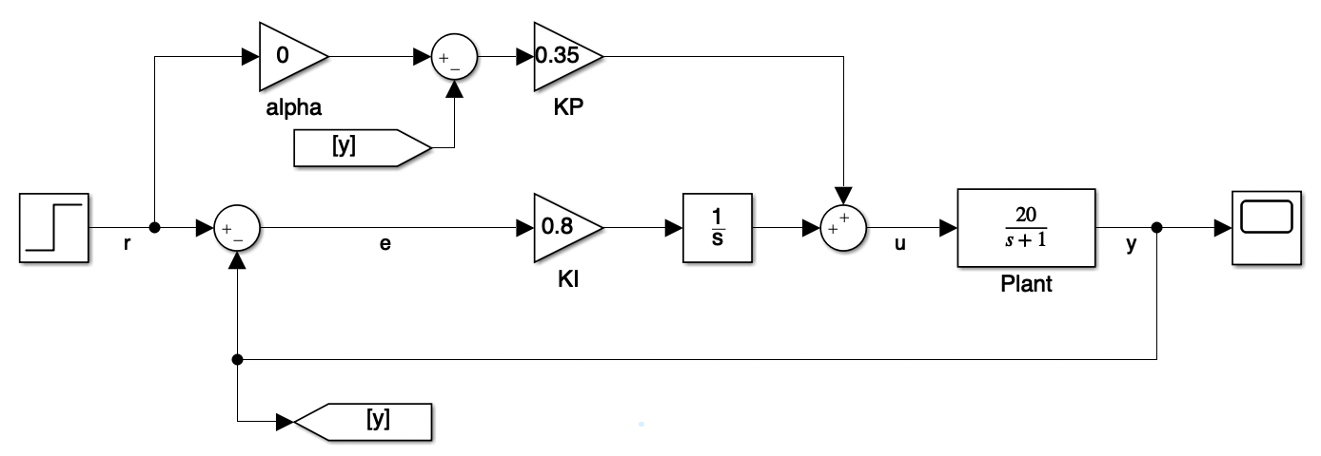

Figure 4: PI controller with set point weight for KP.

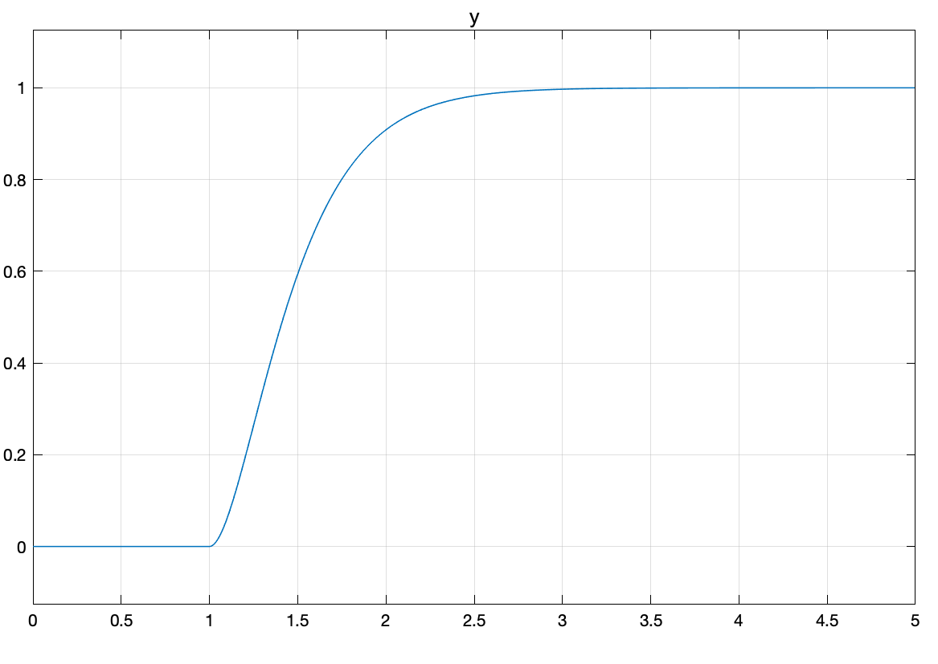

Figure 5: Step response of closed-loop for PI controller with set point weight for KP. (Time in x-axis is in sec).

### Implementation of the Integral Term

The integral term in a PID controller is rarely implemented as is. This is due to the integrator windup phenomenon. Integrator windup occurs when the error term keeps accumulating over time and the system is unable to implement the control signal due to physical limitation or saturation. This can lead to a delayed response or an overshoot from the setpoint.

Consider the PI control problem discussed above, but now we add a saturation block before the plant as shown in Figure 6. We set the saturation limits of $±0.03$. (We also change the proportional gain setpoint to 1 for reason explained below). If we input a step of 1 at 1 sec followed by another step of -1 at 5 sec, we observe that the output responds to the change in second step at 8.2 sec instead of 5 sec, as shown in Figure 7 (a). This is due to integrator windup. The control signal before and after the saturation block is shown in Figure 7 (b). We observe that the control signal before the saturation block continuously builds up until 5 sec. After the second step input at 5 sec, the control signal starts decreasing and matches the signal after the saturation block only after 8.2 sec.

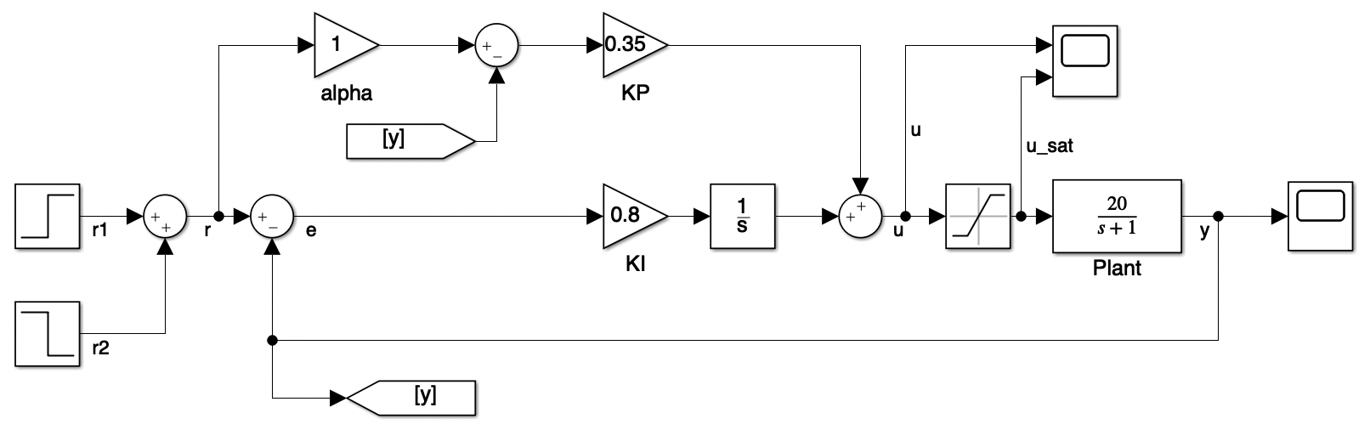

Figure 6: Closed-loop system with plant input saturation.

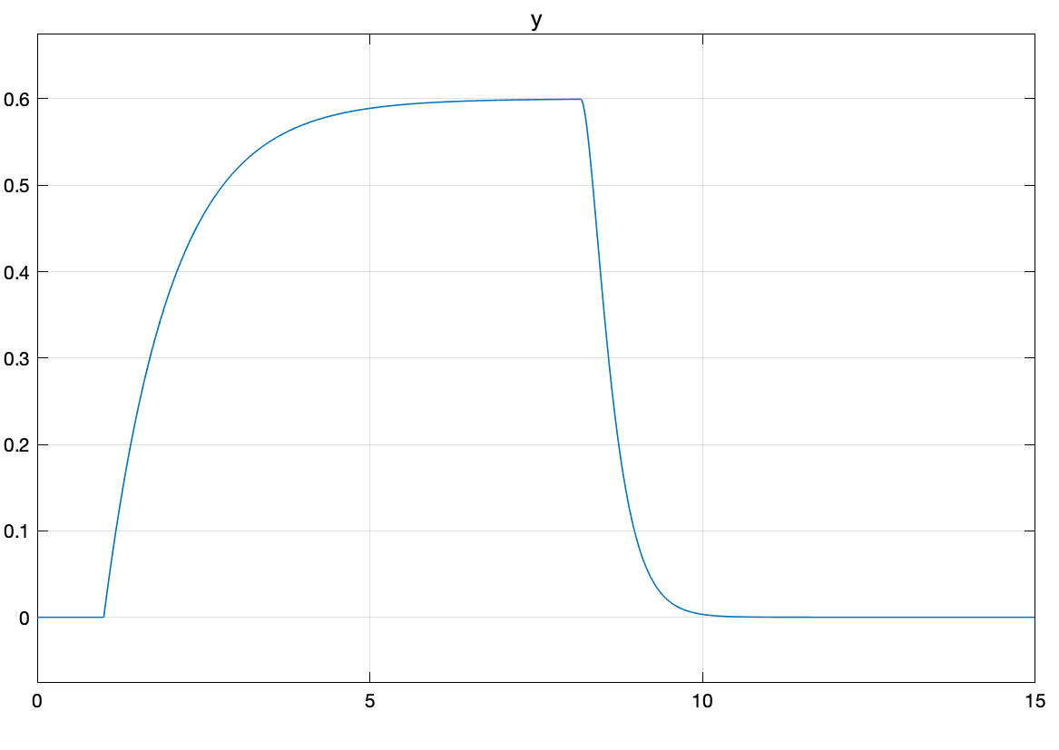

(a)

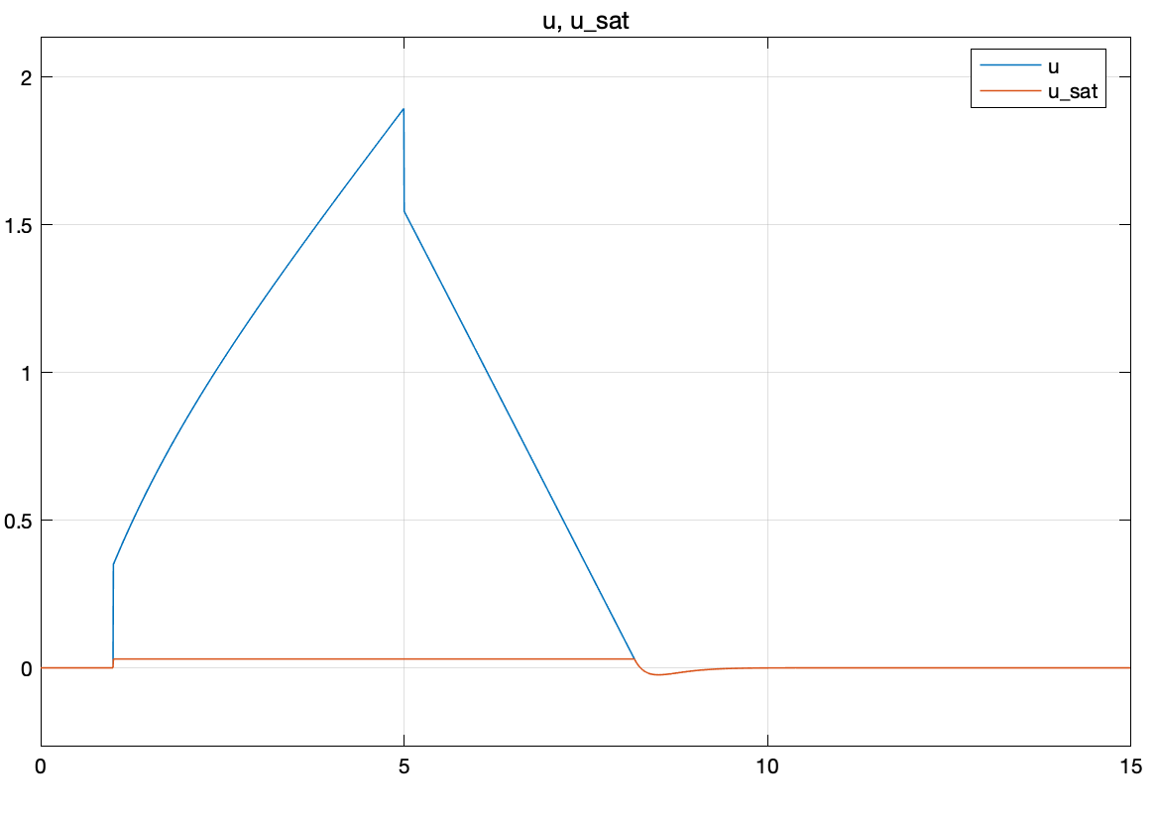

(b)

Figure 7: (a) Step response for plant with input saturation (b) Control signal before and after plant input saturation block.

There are several strategies which can be implemented to prevent integrator windup. These are listed below:

* 1. Limiting the min/max value of the integrator state.
  2. Disabling PI control integrator during plant input saturation.
  3. Implementing an anti-windup filter.

### Anti-windup mechanism 1: Limiting the min/max value of the integrator state

One of the strategies to avoid the integrator windup is to add a limit to the min/max value of the output of the integrator. The Simulink implementation is shown in Figure 8.

In this example we limit the output of the integrator to be $±0.25$. With this we see that the output signal immediately responds to the change in the step input at 5 sec as shown in Figure 9 (a). The control signal is shown in Figure 9 (b). However, the steady-state does not reach of 1. This is because of the input saturation of the plant.

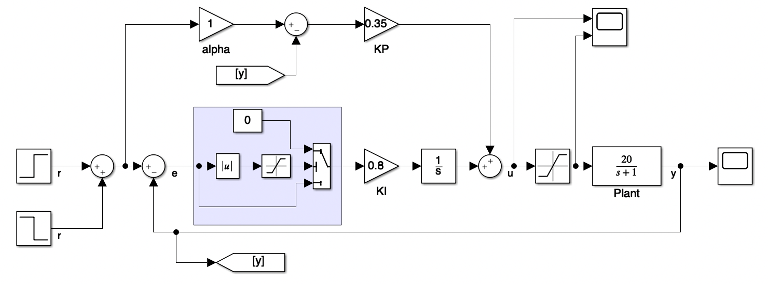

Figure 8: Closed-loop system with saturation limit on input to KI. The integral gain limiting is shown by the shaded area.

|  |  |
| --- | --- |
| (a) | (b) |

Figure 9: (a) Step response for plant with integral limiting (b) Control signal showing input saturation.

### Anti-windup mechanism 2: Disabling PI control integrator during plant input saturation

The second strategy is to disable the integrator when the difference between the input and output of the plant saturation block is greater than a threshold. This will help in stopping the buildup of the integrator signal when the error is high and will prevent windup.

The implementation of this mechanism is shown in Figure 10. Here the threshold is chosen as 0.01. The integrator for the PI controller is modified into an enabled system. This block is enabled only when the saturation error is lower than the threshold.

The plant and the controller responses are shown in Figure 11. Note that the plant response for the second step changes almost immediately. We observe an oscillation in the control signal. This is because of a high frequency switching of the enabling signal. This occurs because when the integrator is enabled, the control signal increases and creates an error which when greater than the threshold causes the integrator path of the PI controller to disable. Hence, this scheme as implemented may not be ideal for anti-windup.

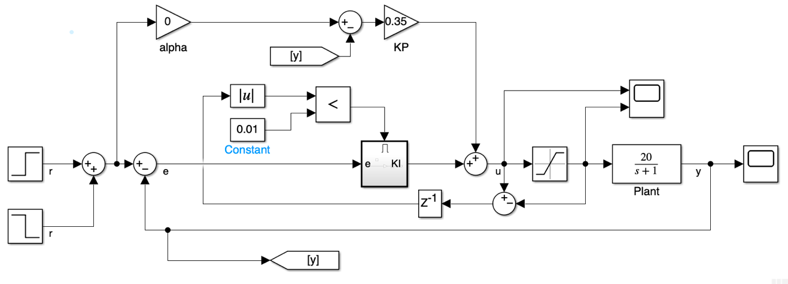

Figure 10: Closed-loop system with mechanism for disabling the integrator gain during plant input saturation.

|  |  |
| --- | --- |
| (a) | (b) |

Figure 11: (a) Step response of the plant with anti-windup scheme involving disabling of the integrator (b) Corresponding control signal.

### Anti-windup mechanism 3: Implementing of anti-windup filter

A third strategy is to use an anti-windup filter. In this case, the difference between the input and output of the plant input saturation block is subtracted from the input to the integrator with an anti-windup gain.

The implementation in Simulink is shown in Figure 12. The anti-windup gain is chosen as 3. The step response of the plant and the corresponding control signal are show in Figure 13. Note that the plant responds immediately to the second step command. The steady-state response of the plant does not reach 1 due to the input saturation.

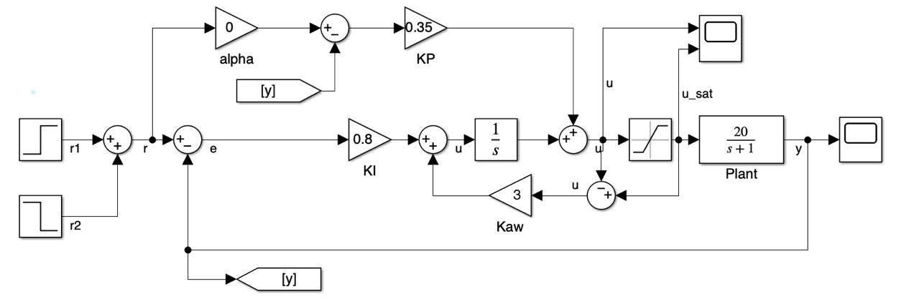

Figure 12: Closed-loop implementation with anti-windup filter.

|  |  |
| --- | --- |
| (a) | (b) |

Figure 13: (a) Step response for the plant with anti-windup filter. (b) Control signal showing input saturation.

## Implementation of a PID controller

In this section, we will show how to implement the derivative term along with the proportional and integral term as discussed above.

## Implementation of the Derivative Term.

The derivative term of a PID controller is a non-causal when implemented as a pure derivative. In control theory, a non-causal system refers to a system whose output depends on future input values, which is not physically realizable. In practical implementations, it's not possible to directly measure the future values of the error signal, making a pure derivative term non-causal. To address this issue, practical implementations of derivative action often use an approximation of the derivative term that depends only on current and past values of the error signal. Common approaches include the backward difference method, central difference method, or a low-pass filtered derivative. These methods make the derivative term causal and prevent it from causing instability or oscillations in the control system.

For continuous-time systems, the derivative term is implemented as a low-pass derivative filter. This can be a system such as $\frac{s}{(τs+1)}$, where $τ$ is chosen as a small positive value. An implementation of the derivative term in a PID controller as a Simulink model is shown in Figure 14. Note that for actual implementation we need to set the setpoint gains on the proportional and derivative paths properly. This is discussed later on in this section.

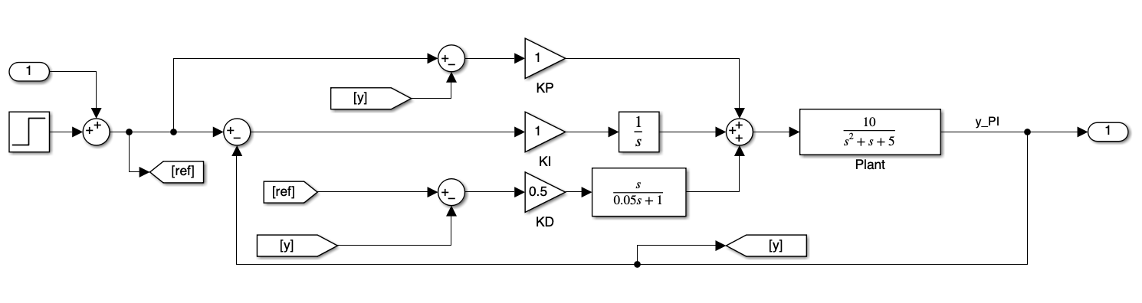

Figure 14: PID controller.

## Usage of derivative term for a PID controller

The derivative term of a PID controller is used to improve the closed-loop damping. The improvement is damping happens because the derivative path anticipates future errors by analyzing the rate of change of the error signal. The derivative action helps to dampen oscillations in the system response. When a system approaches its setpoint, the error diminishes, but without derivative action, the controller might overshoot or oscillate around the setpoint due to inertia. The derivative term anticipates this change and slows down the control output, thus reducing overshoot and oscillation.

Let us demonstrate this by presenting a design example. A Simulink model for closed-loop implementations of a PI and a PID controller is shown in Figure 15. Here the plant is a low damped second order system given by $\frac{10}{s^{2}+s+5}$ which has a damping ratio of $2.2361×{10}^{-1}$. Both the proportional gain, KP, and the integral gain, KI are chosen are selected as 1. If we simulate the closed-loop, we get an oscillatory response for the PI controller as shown by the solid line in Figure 16. The closed-loop poles are shown below. Note that the lowest damping ratio is $1.7131×{10}^{-1}$, which denotes that the closed-loop system has low damping.

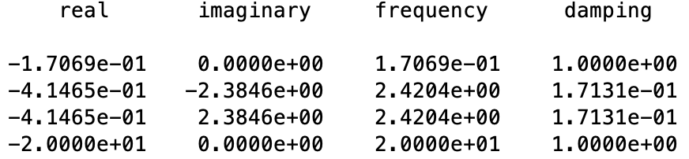

With the derivate gain selected as 0.5 (by trial and error), the oscillations are removed as shown by the dashed line in Figure 16. The closed-loop poles are shown below. Note that the damping ratio of all the poles have changed to 1.

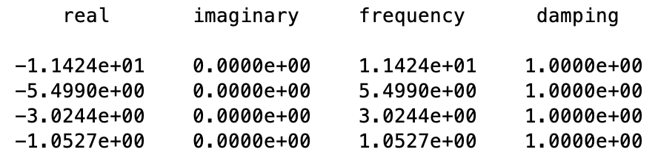

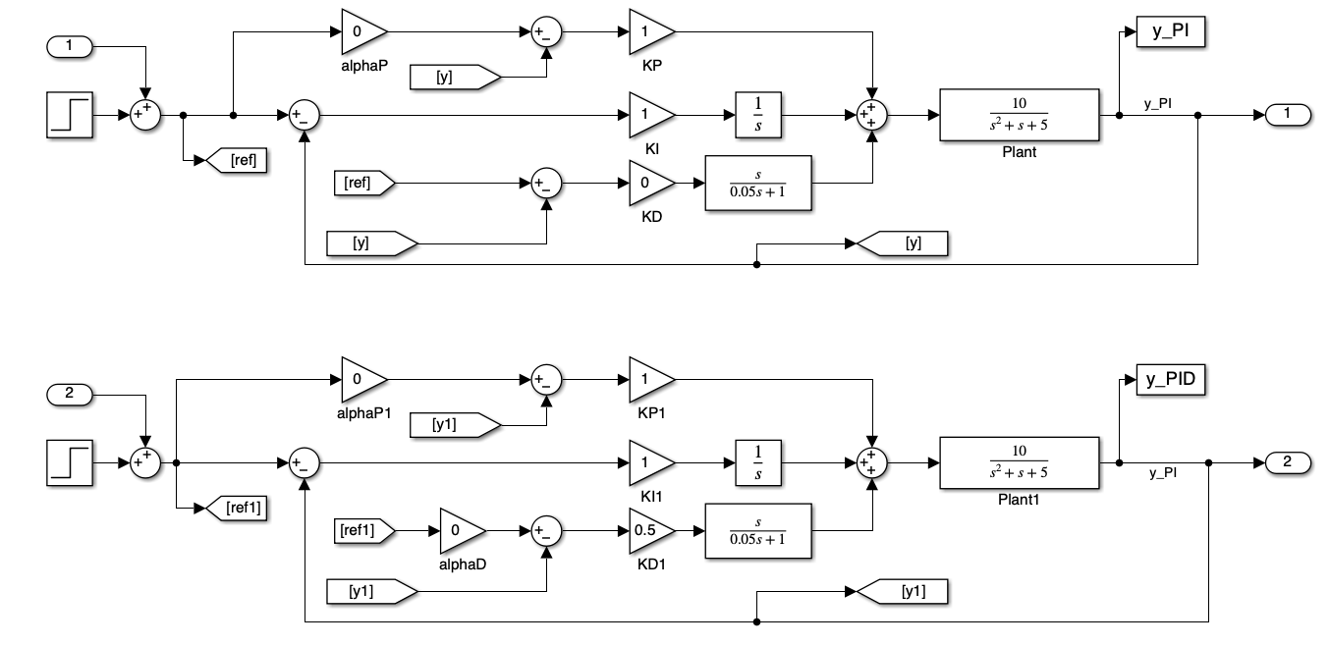

Figure 15: Simulink implementation of PI and PID controllers.



Figure 16: Step responses of closed-loop system with PID controller and comparison with that of a PI controller.

It is important to note that the derivative term is implemented with a set-point gain ($α_{D}$) of zero in the reference signal feedback path. In other words, the feedback signal is the negative of the error signal formed by the difference between the reference signal and the plant output and not the reference signal. This is similar to the proportional path and is done to remove complex pair of zeros with low damping (frequency of 1.41 rad/sec in the closed-loop response and damping ratio of 3.54 $×{10}^{-2}$). The comparison between the implementation with and without $α_{D}$ set to zero is shown in Figure 17.



Figure 17: Closed-loop response for derivative path setpoint set ($α_{D}$) as 1 and 0.

## Lead Compensator

One of the drawbacks of implementing derivative control in PID is an amplification of noise in the controller output. Derivative action in a PID controller calculates the rate of change of the process error, which is useful for predicting the future behavior of the error. However, since differentiation tends to amplify high-frequency signals, any noise present in the error signal can be significantly amplified, leading to erratic or overly aggressive control actions. This effect is particularly problematic in systems where the measurement signals are noisy or when the system itself has high-frequency dynamics that are not well-damped.

One of the ways to mitigate this is the usage of a *lead compensator* along with a PI controller. The goal of the lead compensator is to add phase to the closed-loop system when the phase margin is low. The lead compensator is modeled as a transfer function shown below:

|  |  |
| --- | --- |
| $$K_{lead}=K\frac{(s+z)}{(s+p)}.$$ | (3) |

Thus, if the zero (z) of the transfer function is lower than the pole (p) then the compensator phase increases between the zero and the pole. This can be observed in the frequency response of an example lead compensator $10\frac{(s+1)}{(s+10)}$. This compensator adds a maximum phase angle of about 55 degrees at a frequency of 3.1 rad/sec as shown in Figure 18.



Figure 18: Frequency response of lead compensator $10\frac{(s+1)}{(s+10)}$.

In order to design a lead compensator, we need to calculate the phase margin and corresponding frequency, $ω$, of the closed-loop system. If we decided to add a phase of $ϕ$ based on the desired phase margin, then the terms *K*, *z*, and *p* of the lead compensator can be calculated as follows.

|  |  |
| --- | --- |
| $$α=\frac{1-\sin\left(ϕ\right)}{1+sin⁡(ϕ)}$$ |  |
| $$T=\frac{1}{ω\sqrt{α}}$$ | (4) |
| $$z=\frac{1}{T}$$ |  |
| $$p=\frac{1}{αT}$$ |  |
| $$K=\frac{1}{α}$$ |  |

We will illustrate this by an example. Let us consider the plant with transfer function $\frac{10}{s^{2}+s+5}$ as we were using in the previous section. In order to calculate the parameters of the lead controller, we first need to calculate $ω$. We do this by looking at the open-loop response of the plant with just the proportional and integral gains (since we will be adding the lead controller to this system). The proportional gain *KP* is selected as 1 and the integral gain *KI* is selected as 0.5.The bode plot with the gain and phase margins are shown in Figure 19. From this we see that the cross-over frequency is 3.79 rad/sec. Selecting a desired phase margin of 40 deg, we calculate the lead controller gain, pole and zero as *K* = 4.60, *p* = 8.13 rad/sec and *z* = 1.77 rad/sec.

With the above, we now implement the closed-loop system in Simulink. In Figure 20, we show the Simulink implementation of the PID controller we earlier designed at the top and a PI controller with a lead compensator at the bottom. The PID controller gains are selected as *KP* = 1, *KI* = 0.5, and *KD* = 0.5. The closed-loop and the controller responses of the two closed-loop systems with a sinusoidal output noise of amplitude 0.001 and frequency 50 rad/sec are plotted in Figure 21. We observe that the controller response for the PI with lead controller is considerably less noisy than the PID controller. Thus, we conclude that the lead compensator does a better job of noise reduction than the derivative based PID controller.



Figure 19: Gain and phase margin of the PI open-loop system

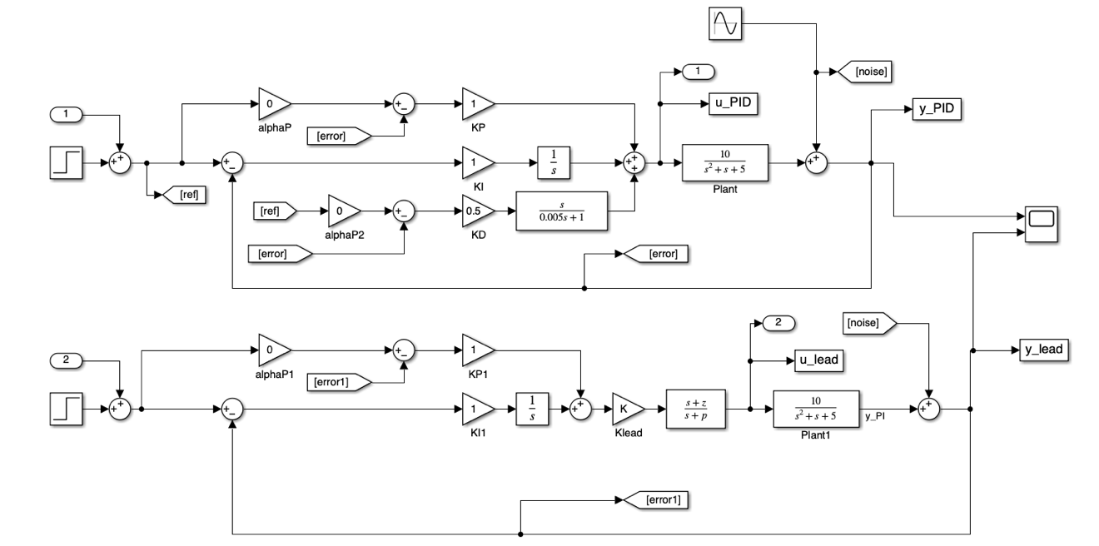

Figure 20: Closed-loop system for the PID controller and the PI with lead controller.

|  |  |
| --- | --- |
|  |  |

Figure 21: PID and lead controller closed-loop and controller responses

## Position and Velocity Control Using Acceleration Input

Let us look at a classic problem of position control using acceleration input. The dynamics of a position control system using acceleration can be formulated as:

$$\ddot{x}=u$$

where *x* is the position and *u* is the control input. We will consider two cases (a) where both position and velocity can be measured, and (b) where we only have position measurement available.

Using Laplace transform, the above equation can be written as

$$\frac{X}{U}=\frac{1}{s^{2}}$$

In other words, there are two *pure integrators* in the plant. We call this the *double integrator* problem.

The control solution to the double integration is not straight forward.

# Dynamic Inversion Controller

## Introduction

Dynamic inversion control is a modern control strategy utilized in various engineering fields to achieve precise and robust control of complex dynamical systems. This approach leverages the concept of dynamic inversion, where the dynamic behavior of the system is inverted to create a control law that compensates for the system's inherent nonlinearities and uncertainties.

At its core, dynamic inversion control aims to design a control law that cancels out the nonlinearities and dynamics of the system, effectively transforming it into a linear and easily controllable system. This is achieved by modeling the dynamics of the system and then synthesizing a feedback control law that effectively "inverts" these dynamics. By doing so, the control system is able to achieve high performance and stability across a wide range of operating conditions.

One of the key advantages of dynamic inversion control is its ability to handle highly nonlinear systems without requiring extensive knowledge of their internal dynamics. This makes it particularly well-suited for controlling systems with complex and uncertain dynamics, such as aerospace vehicles, robotic manipulators, and chemical processes.

In this chapter, we

## Dynamic inversion controller design

Dynamic inversion control is a control technique used in the field of aerospace engineering, particularly for the control of nonlinear systems such as aircraft. It involves designing a control law that cancels out the nonlinearities of the system, resulting in a linearized representation that can be more easily controlled using conventional control techniques.

Here's a basic outline of how the dynamic inversion controller is derived:

1. **System Modeling**: Begin with a mathematical model of the system you want to control. This model should capture the dynamics of the system, including any nonlinearities. For example, in aircraft control, this might involve equations describing the aircraft's motion, such as equations of motion, aerodynamic forces, etc.
2. **Dynamic Inversion**: Identify the nonlinearities in the system model that make it difficult to control. These could be terms like nonlinearities in the aerodynamic forces, gravitational forces, etc. The idea of dynamic inversion is to design a control law that cancels out these nonlinearities.
3. **Linearization**: Linearize the system around a desired operating point. This involves approximating the nonlinear system with a linear one in the vicinity of the operating point. This is typically done using techniques such as Taylor series expansion.
4. **Control Law Design**: Design a control law based on the linear or nonlinear model. This control law should aim to cancel out the effects of the linear dynamics and nonlinearities identified earlier. The control law should also provide stability and performance guarantees for the closed-loop system.

Let us begin with the mathematics of dynamic inversion. Consider a state space representation of a linear system which has state-space matrices as *A, B, C* and *D*. We take a special case where *D* = 0. (Note that this can be derived for a state space system with *D $≠$*  0 by adding a low pass filter at the input of the plant).

# Model Predictive Controller

Part 2:

Control Applications

F-16 Aircraft Model

# F-16 Model and Simulations

The F-16 aircraft is a multirole fighter jet that has been widely used by various air forces around the world. Developed by General Dynamics (now Lockheed Martin), the F-16 is known for its agility, versatility, and advanced avionics. The F-16 was designed in the 1970s as a lightweight, cost-effective fighter aircraft with a focus on air-to-air combat. It is renowned for its exceptional maneuverability, often attributed to its relaxed static stability and fly-by-wire control system. It has a top speed of over Mach 2 (twice the speed of sound) and can climb at a rate of 50,000 feet per minute.

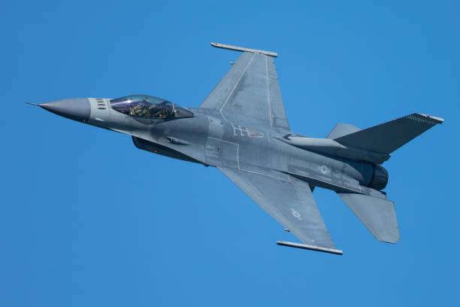

Figure 22: F-16 Aircraft

This section presents a MATLAB/Simulink F-16 aircraft model as developed by (Stevens et al., 2003). First, the aircraft equations of motion are introduced. Next, a Simulink model is developed for the F-16 aircraft. This is followed by simulations of the Simulink model of the F-16 aircraft.

## Equations of Motion

Let us begin with the equations of motion (EOM) of a 6 degrees of freedom (DOF) of an aircraft. We assume that the reader is somewhat familiar with aircraft literature – so these are not derived here. The following notations are used in this text:

*V*: aircraft velocity

$α$: angle of attack

$β$: side slip angle

$γ$: flight path angle

$u:$ body axis *x* velocity

$v:$ body axis *y* velocity

$w:$ body axis *z* velocity

$ϕ$: roll angle

$θ$: pitch angle

$ψ$: yaw angle

*p*: roll rate

*q*: pitch rate

*r*: yaw rate

$X_{e}$: inertial *x* displacement

$Y_{e}$: inertial *y* displacement

$Z_{e}$: inertial *z* displacement

*h*: altitude

*g*: acceleration due to gravity

*m*: aircraft mass

*J*:aircraft inertia (subscripts *x*, *y*, *z* refers to the body axis coordinates)

*F*: aircraft force (subscripts *x*, *y*, *z* refers to the body axis coordinates)

*M*: aircraft moment (subscripts *x*, *y*, *z* refers to the body axis coordinates)

Given the above notations, the aircraft 6 DOF equations of motion are:

|  |  |
| --- | --- |
| Force Equations: $$\frac{F_{x}}{m}=\dot{u}-rv+qw+g\sin{θ}$$ $$\frac{F_{y}}{m}=\dot{v}+ru-pw-g\sin{ϕ\cos{θ}}$$ $$\frac{F_{z}}{m}=\dot{w}-qu+pv-g\cos{ϕ\cos{θ}}$$ Kinematic Equations: $$\dot{ϕ}=p+\tan{θ}(q\sin{ϕ+r\cos{ϕ})}$$ $$\dot{θ}=q\cos{ϕ} -r\sin{ϕ}$$ $$\dot{ψ}=(q\sin{ϕ}+r\cos{ϕ})/\cos{θ}$$ Moment Equations: $$M_{X}=I_{X}\dot{p}-I_{xz}\dot{r}+qr(I_{z}-I_{y})$$ $$M_{y}=I_{Y}\dot{q}+rp\left(I_{x}-I_{z}\right)+I_{xz}(p^{2}-r^{2})$$ $$M_{z}=-I_{xz}\dot{p}+I_{z}\dot{r}+pq\left(I_{y}-I_{x}\right)+I_{xz}qr$$ Navigation Equations: $${\dot{X}}_{e}=u\cos{θ\cos{ψ}+v(-}\cos{ϕ\sin{ψ}+}\sin{ϕ\sin{θ}\cos{ψ})+w}(sin{ϕ\sin{ψ}+}\cos{ϕ}\sin{θ}\cos{ψ)}$$ $${\dot{Y}}_{e}=u\cos{θ\sin{ψ}+v(}\cos{ϕ\cos{ψ}+}\sin{ϕ\sin{θ}\sin{ψ})+w}(-sin{ϕ\cos{ψ}+}\cos{ϕ}\sin{θ}\sin{ψ)}$$ $$\dot{h}=u\sin{θ-v\sin{ϕ}}\cos{θ}-w\cos{ϕ\cos{θ}}$$ | (5) |

The body axis velocities can be converted to aircraft velocity, angle of attack and side slip angle using the following equations:

|  |  |
| --- | --- |
| $$V=\sqrt{u^{2}+v^{2}+w^{2}}$$ $$α=\tan^{-1}{\frac{u}{w}}$$ $$β=\sin^{-1}{\frac{v}{V}}$$ | (6) |

The flight path angle is given by:

|  |  |
| --- | --- |
| $$γ=θ-α$$ | (5) |

## MATLAB/Simulink Model – Trim and Linearization

The code for the F-16 aircraft dynamics is presented in Appendix B. The code given in (Stevens et al, 2003) is written in Fortran and these are converted into MATLAB in this book.

In order to simulate the model at an equilibrium point, we first need to trim the aircraft. This is done by reducing a cost function as given by the code in F16COST.m. For straight and level flight, the trim condition is specified by the equilibrium velocity $V_{0}$, altitude $h_{0}$ and cg location $x_{CG}. In order to trim the aircraft,$ the first 9 states from the state vector *x* are passed to F16COST.m from DOTRIM.m. These are $V, α, β, ϕ, θ, ψ, p, q, r.$ Inside F16COST.m, all of the 13 states are initialized as zero, except for velocity (state 1) , altitude (state 12) and power (state 13). The power is given by TGEAR(throttle). The control vector $[δ_{th} δ_{e} δ_{a} δ_{r}]^{T}$ (throttle, elevator, aileron and rudder) is initialed as [0 0 0 0]*T.* The input to F16COST.m is $z=[V, α, β, ϕ, θ, ψ, p, q, r{,δ}_{th} δ_{e} δ_{a} δ_{r}]^{T}$.

The cost is given by the quadratic term $Q^{T}HQ$ where *Q* is a constraint term and is a vector given the following vector:

$${Q=[\dot{x}\left(1:9\right), \left(V-V_{0}\right), γ, β, ϕ, θ, ψ, p, q, r]}^{T}$$

Here, $γ$ is the flight path angle which is zero for straight and level flight. The term *H* is set as 1000 x *I*13. When the cost is minimized, the term *Q* tends to zero.

The Simulink model F16sim_lin.slx shown in Figure 25 is used to trim the aircraft. The corresponding code is given in DOTRIM.m in Appendix B. The MATLAB function for the aircraft dynamics is given in F16DYN.m

For the trim condition $V_{0}=502$ ft/sec, altitude $h_{0}=0$ ft and cg location $x_{CG}=0.35$, the cost term is 1.2319 x 10-4. The trim condition *z*\* is calculated as:

$$z^{*}=[502.0000 0.0505 -0.0000 0.0001 0.0505 0.0000 -0.0001 -0.0000 -0.0000 0.1540 -0.6948 0.0018 0.0003]^{T}$$

Where the unit for z $=[V, α, β, ϕ, θ, ψ, p, q, r{,δ}_{th} δ_{e} δ_{a} δ_{r}]^{T}$ are [ft/sec rad rad rad rad rad rad/sec rad/sec rad/sec % rad rad rad]. Once the aircraft trim values are calculated, we can linearize the aircraft model. The Simulink model for linearization is shown in Figure 25. After linearization, the state space matrices $A,B,C,D$ are separated for the longitudinal and lateral dynamics.



Figure 23: Simulink model for trimming the aircraft model.

|  |  |
| --- | --- |
| (a) | (b) |
| (c) | (d) |

Figure 24: Actuator models – (a) Throttle (b) Elevator (c) Aileron (d) Rudder. The rate and control saturation values are given in Appendix A.



Figure 25: Simulink model for linearizing the aircraft model.

The *A* and *B* matrices for the longitudinal dynamics is given by:

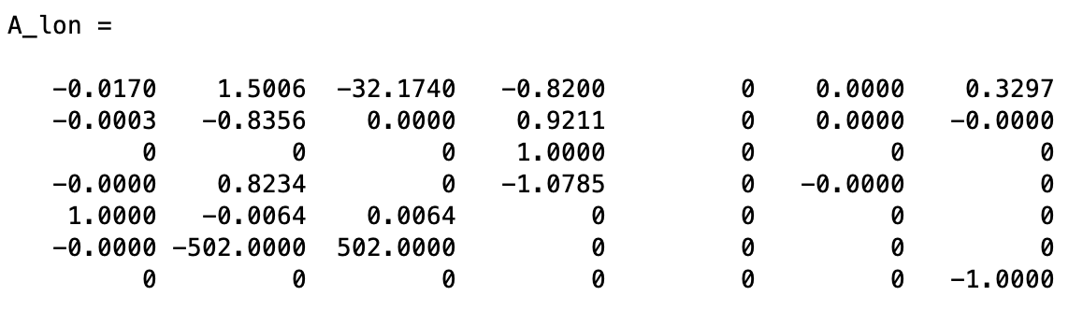

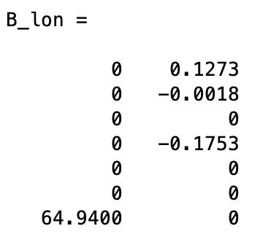

The state vector for the longitudinal dynamics is $[V,α,θ,q,X_{e},h,p{ow]}^{T}$ (where *pow* is power) and the control vector is [$δ_{th} δ_{e}]^{T}$.

The *A* and *B* matrices for the lateral dynamics is given by:

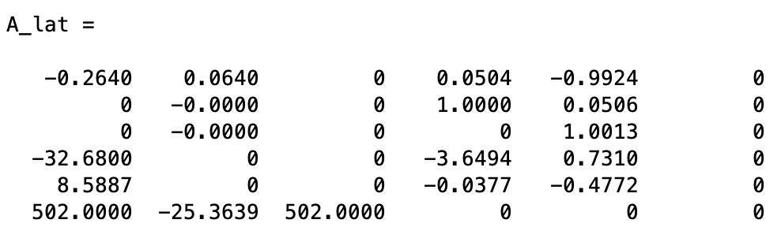

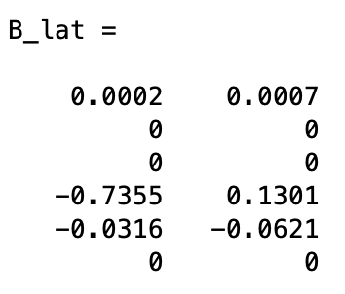

The state vector for the longitudinal dynamics is $[β,ϕ,ψ,p,r,Y_{e}]^{T}$ (where *p* is power) and the control vector is [$δ_{a} δ_{r}]^{T}$.

After linearization, we simulate the models with step inputs in $[δ_{th} δ_{e} δ_{a} δ_{r}]^{T}$. The corresponding plots are shown in Figure 26 to Figure 33. We observe that except for the states which are directly affected by the inputs (*V*, *pow* for $δ_{th}$; $α$ $,θ,q$ for $δ_{e}$; $ϕ$, *p* for $δ_{a}$; and $β,$*r* for $δ_{r}$), the deviations for the rest of the states are minimal. This is expected for the trim condition simulations.



Figure 26: V and $α$ for linearized model with 10% step input in throttle.



Figure 27: $θ$, q, and pow for linearized model with 10% step input in throttle.



Figure 28: V and $α$ for linearized model with 1 deg step input in elevator..



Figure 29: $θ$, q, and pow for linearized model with 1 deg step input in elevator.



Figure 30: $β$ and $ϕ$ for linearized model with 1 deg step input in aileron..



Figure 31: $ψ$, p and r for linearized model with 1 deg step input in aileron..



Figure 32: $β$ and $ϕ$ for linearized model with 1 deg step input in rudder.

.

Figure 33: $ψ$, p and r for linearized model with 1 deg step input in rudder..

## Pitch Rate Control for Longitudinal Dynamics

In this section, we present a pitch rate controller for the F16 plant using dynamic inversion. The aircraft is straight and level and is linearized at $V_{0}=502$ ft/sec, altitude $h_{0}=0$ ft and cg location $x_{CG}=0.35$. We will simulate the linear and nonlinear controllers and compare the step responses.

The Simulink diagram in Figure 34 shows the closed-loop system with the linearized plant. The plant is modeled using the longitudinal state space matrices mentioned earlier. Please refer to the chapter TBD to understand the controller structure. The controller gains are selected as *Kq = 4*, *fc =* 0.5, and *fi* = 0.25. The *C* matrix is [0, 0, 0, 1, 0, 0 0] which corresponds to pitch rate feedback.

The Simulink diagram in shows the closed-loop system Figure 35 with the nonlinear plant. (The dynamics in modeled in F16DYN.m). The key difference in the setup is that the trim values of the control signals is added to the controller output and the trim values of the plant states is subtracted.

The pitch rate and elevator responses for the linear and nonlinear closed-loop systems are plotted in Figure 36. It is observed that the responses match very closely.



(a)



(b)



(c)

Figure 34: Pitch rate controller for linear plant: (a) Closed-loop system (b) Plant (c) Controller

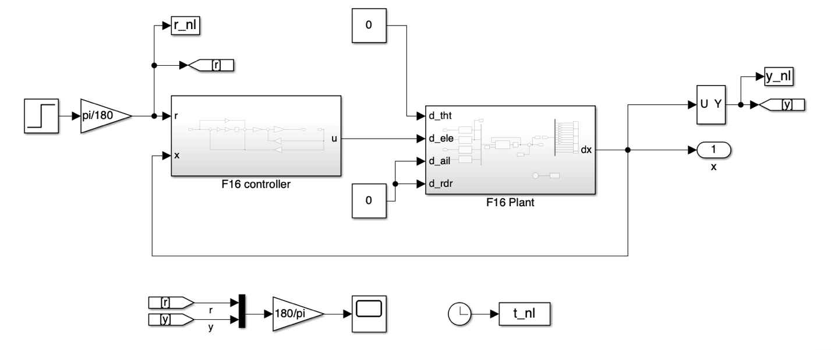

(a)

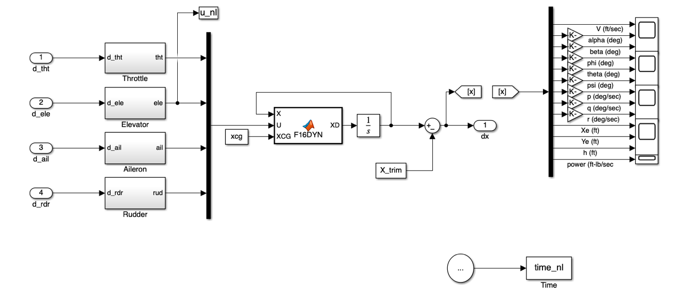

(b)

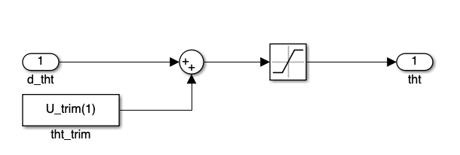

(c)

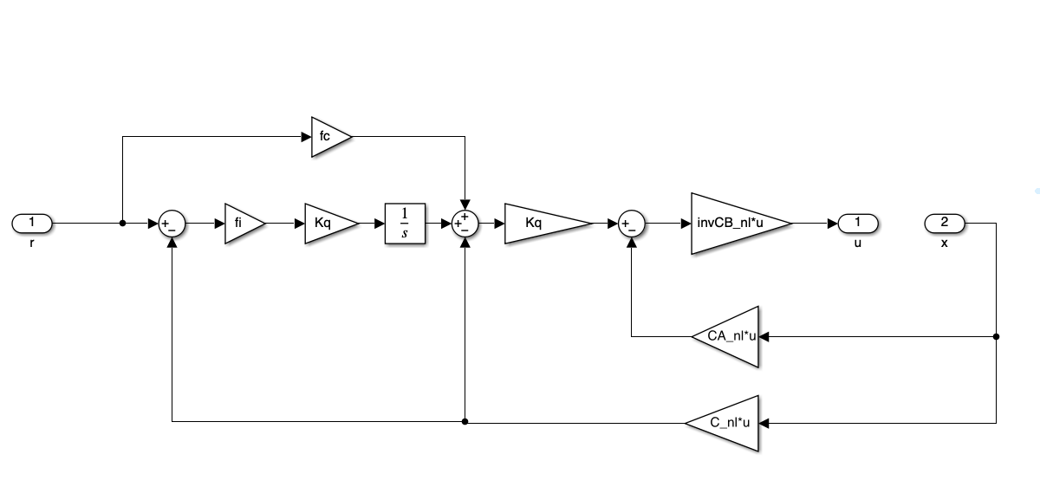

(d)

Figure 35: Pitch rate controller for linear plant: (a) Closed-loop system (b) Plant (c) Throttle (d) Controller



Figure 36: Pitch rate and elevator responses for linear (solid) and nonlinear (dashed) closed-loop systems. The responses match very closely.

## Roll, Pitch and Yaw Rate Control

In this section, we present the aircraft rotation rate control for all the three axis. The roll rate is controlled by the aileron, the pitch rate is controlled by the elevator, while the yaw rate is controlled by the rudder.

As we know from before, the goal of the dynamic inversion controller is to invert the plant dynamics and replace it with the desired dynamics. However, for the nonlinear F16 aircraft model, the dynamics is not invertible. We can observe this from the function PDOT.m which is shown below:

function PDOT_OUT = PDOT(P3,P1)

% PDOT_OUT = rate of change of power

% Author: Subhabrata Ganguli

%

% Ref: Stevens, Brian L.; Lewis, Frank L.; Johnson, Eric N..

% Aircraft Control and Simulation: Dynamics,

% Controls Design, and Autonomous Systems.

% Wiley.

% P3 = actual power

% P1 = power command

if (P1 >= 50)

if (P3 >= 50)

T = 5;

P2 = P1;

else

P2 = 60;

T = RTAU(P2-P3);

end

else

if (P3 >= 50)

T = 5;

P2 = 40;

else

P2 = P1;

T = RTAU(P2-P3);

end

end

PDOT_OUT = T*(P2-P3);

end

Note that for P1 $≥$ 50 and P3 $<$ 50, P2 is always equal to 60. This means that we will get the same PDOT_OUT for all values of P1 $≥$ 50 and P3 $<$ 50 since PDOT = RTAU(P2-P3). Thus, if we want to invert the function to get P1 from PDOT_OUT and P3, we will not get a unique value. In other words, the function is not invertible. A similar argument holds for the function RTAU.m.

Hence, we make a slight alteration to the function to get invertibility. We add a perturbation term to PDOTINV_K.m and RTAU_K.m. In PDOTINV_K.m we add the term “0.1*P1” as shown below:

function [P1_OUT] = PDOTINV_K(P3,PDOT_IN)

% Author: Subhabrata Ganguli

%

% Ref: Stevens, Brian L.; Lewis, Frank L.; Johnson, Eric N..

% Aircraft Control and Simulation: Dynamics,

% Controls Design, and Autonomous Systems.

% Wiley.

% P3 = actual power

% P1 = power command

% PDOT_IN = power rate

if isempty(P3)

disp('empty')

end

ctr = 1;

n = length(0:0.01:100);

P1_OUT_vec = inf*ones(n,1);

err = inf*ones(n,1);

for P1 = 0:0.01:100

if (P1 >= 50)

if (P3 >= 50)

T = 5;

P2 = P1;

else

P2 = 60 + 0.1*P1;

T = RTAU_K(P2-P3);

end

else

if (P3 >= 50)

T = 5;

P2 = 40 + 0.1*P1;

else

P2 = P1;

T = RTAU_K(P2-P3);

end

end

PDOT_OUT = T*(P2-P3);

P1_OUT_vec(ctr) = P1;

err(ctr) = abs(PDOT_OUT - PDOT_IN);

ctr = ctr + 1;

end

[~,idx] = min(err);

P1_OUT = P1_OUT_vec(idx);

end

For RTAU_K.m, we add a similar perturbation term “0.01*DP” as shown below to make it invertible.

function RTAU_OUT = RTAU_K(DP)

% function used by PDOT

% Author: Subhabrata Ganguli

%

% Ref: Stevens, Brian L.; Lewis, Frank L.; Johnson, Eric N..

% Aircraft Control and Simulation: Dynamics,

% Controls Design, and Autonomous Systems.

% Wiley.

if (DP < 25)

RTAU_OUT = 1 + 0.01*DP;

elseif (DP > 50)

RTAU_OUT = 0.1 + 0.01*DP;

else

RTAU_OUT = 1.9 -.036 * DP;

end

Note that the functions PDOTINV_K.m and RTAU_K.m are only called by the dynamic inversion function F16DYNINV.m in the controller. Hence the suffix ‘_K’ is added. The plant model represented by the actual aircraft dynamics is not affected with these changes.

The Simulink model for the roll-pitch-yaw rate control is shown in Figure 37. In Figure 38, we plot the roll-pitch-yaw rate responses for doublet commands. In each row, we plot the responses for each individual axis which are simulated separately. On the left-hand side, the rate responses are plotted. On the right-hand side, the corresponding control responses are plotted. The doublet responses for the rate responses match well with the desired dynamics.

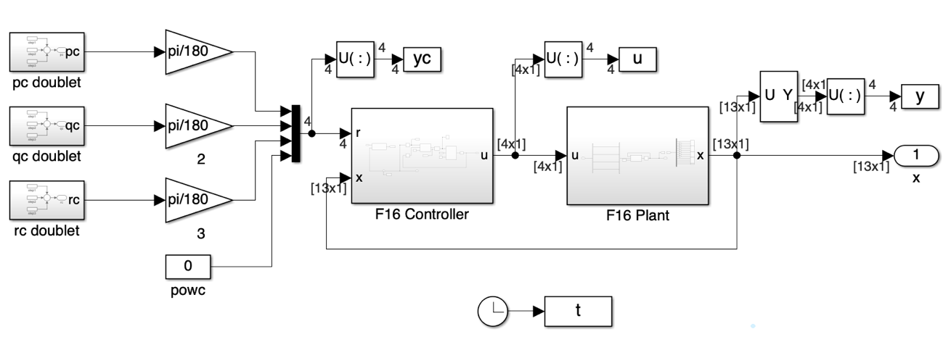

(a)

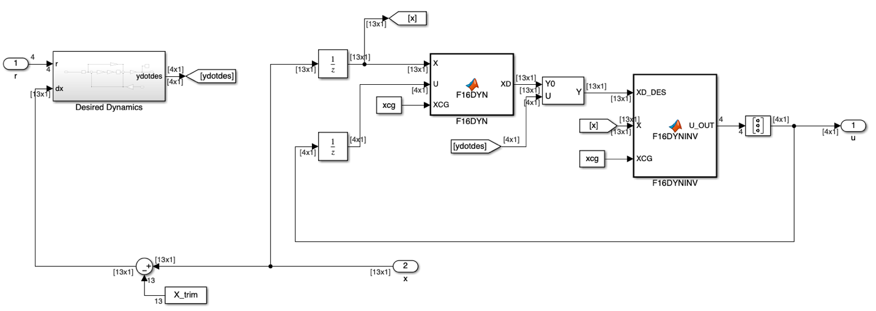

(b)

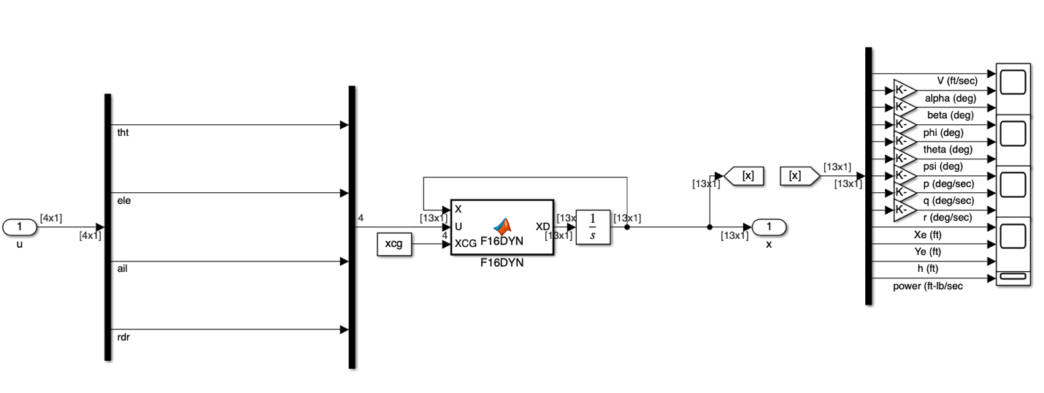

(c)

Figure 37: (a) F16 closed-loop for roll-pitch-yaw rate control (b) F16 controller (c) F16 plant.



Figure 38: Roll-pitch-yaw rate responses for doublet commands.

# Appendix A

The F-16 aircraft modeling data is presented in this appendix. These are obtained from (Stevens et. al., 2003). The code in Appendix B uses these data.

**Mass Properties**

|  |  |
| --- | --- |
| Weight (lb) | $$W=20,500$$ |
| Moment of Inertia (slugs-ft2) |  |

**Wing Dimensions**

|  |  |
| --- | --- |
| Span (ft) |  |
| Area (ft2)  Mean aerodynamic chord ($\overline{c}$) | $$300$$ $$11.32$$ |

**Reference CG Location**

|  |  |
| --- | --- |
| *XCG* |  |
|  |  |

**Control Surface Actuator Models**

|  |  |  |  |
| --- | --- | --- | --- |
|  | deflection limit | rate limit | time constant |
| Elevator | $±25.0$ deg | $$60 deg/sec$$ | $0.0495$ sec lag |
| Aileron | $±21.5$ deg | $$80 deg/sec$$ | $0.0495$ sec lag |
| Rudder | $±30.0$ deg | $$120 deg/sec$$ | $0.0495$ sec lag |

**Engine Angular Momentum**

Assumed fixed at 160 slug-ft2/sec

# Appendix B

function XD = F16DYN(X,U,XCG)

% f16 dynamics

% Author: Subhabrata Ganguli

%

% Ref: Stevens, Brian L.; Lewis, Frank L.; Johnson, Eric N..

% Aircraft Control and Simulation: Dynamics,

% Controls Design, and Autonomous Systems.

% Wiley.

%% Parameters

AXX = 9496.0;

AYY = 55814.0;

AZZ = 63100.0;

AXZ = 982.0;

AXZS = AXZ^2;

XPQ = AXZ * (AXX - AYY + AZZ);

GAM = AXX * AZZ - AXZ^2;

XQR = AZZ * (AZZ - AYY) + AXZS;

ZPQ = (AXX-AYY) * AXX + AXZS;

YPR = AZZ - AXX;

WEIGHT = 20500.0;

GD = 32.174;

MASS = WEIGHT/GD;

S = 300;

B = 30;

CBAR = 11.32;

XCGR = 0.35;

HX = 160;

RTOD = 180/pi;

%% Assign State and Control Variables

VT = X(1);

ALPHA = X(2)*RTOD;

BETA = X(3)*RTOD;

PHI = X(4);

THETA = X(5);

PSI = X(6);

P = X(7);

Q = X(8);

R = X(9);

ALT = X(12);

POW = X(13);

THTL = U(1);

EL = U(2);

AIL = U(3);

RDR = U(4);

XD = zeros(13,1);

%% Air data computer and engine model

[TFAC, T, RHO, AMACH, QBAR, PS ] = ADC(VT, ALT);

CPOW = TGEAR(THTL);

XD(13) = PDOT(POW,CPOW);

T = THRUST(POW,ALT,AMACH);

%% Look-up tables and component buildup

CXT = CX (ALPHA,EL);

CYT = CY (BETA,AIL,RDR);

CZT = CZ (ALPHA,BETA,EL);

DAIL= AIL/20.0; DRDR= RDR/30.0;

DLDA_OUT = DLDA(ALPHA,BETA);

DLDR_OUT = DLDR(ALPHA,BETA);

DNDA_OUT = DNDA(ALPHA,BETA);

DNDR_OUT = DNDR(ALPHA,BETA);

CLT = CL(ALPHA,BETA) + DLDA_OUT*DAIL + DLDR_OUT*DRDR;

CMT = CM(ALPHA,EL);

CNT = CN(ALPHA,BETA) + DNDA_OUT*DAIL ...

+ DNDR_OUT*DRDR;

%% Add damping derivatives

TVT = 0.5/VT;

B2V = B*TVT;

CQ = CBAR*Q*TVT;

D = DAMP(ALPHA);

CXT = CXT + CQ * D(1);

CYT = CYT + B2V * ( D(2)*R + D(3)*P );

CZT = CZT + CQ * D(4);

CLT = CLT + B2V * ( D(5)*R + D(6)*P );

CMT = CMT + CQ * D(7) + CZT * (XCGR-XCG);

CNT = CNT + B2V*(D(8)*R + D(9)*P) - CYT*(XCGR-XCG) * CBAR/B;

%% Get ready for state equations

CBTA = cos(X(3));

U = VT*cos(X(2))*CBTA;

V = VT * sin(X(3));

W = VT*sin(X(2))*CBTA;

STH = sin(THETA);

CTH = cos(THETA);

SPH = sin(PHI);

CPH = cos(PHI);

SPSI = sin(PSI);

CPSI = cos(PSI);

QS = QBAR * S;

QSB = QS * B;

RMQS = QS/MASS;

GCTH = GD * CTH;

QSPH = Q * SPH;

AY = RMQS*CYT;

AZ = RMQS * CZT;

%% Force Equations

UDOT = R*V - Q*W - GD*STH + (QS * CXT + T)/MASS;

VDOT = P*W - R*U + GCTH * SPH + AY;

WDOT = Q*U - P*V + GCTH * CPH + AZ;

DUM = (U*U + W*W);

XD(1) = (U*UDOT + V*VDOT + W*WDOT)/VT;

XD(2) = (U*WDOT - W*UDOT) / DUM;

XD(3) = (VT*VDOT- V*XD(1)) * CBTA / DUM;

%% Kinematics

XD(4) = P + (STH/CTH)*(QSPH + R*CPH);

XD(5) = Q*CPH - R*SPH;

XD(6) = (QSPH + R*CPH)/CTH;

%% Moments

ROLL = QSB*CLT;

PITCH = QS *CBAR*CMT;

YAW = QSB*CNT;

PQ = P*Q;

QR = P*R;

QHX = Q*HX;

XD(7) = ( XPQ*PQ - XQR*QR + AZZ*ROLL + AXZ*(YAW + QHX) )/GAM;

XD(8) = ( YPR*P*R - AXZ*(P^2 - R^2) + PITCH - R*HX )/AYY;

XD(9) = ( ZPQ*PQ - XPQ*QR + AXZ*ROLL + AXX*(YAW + QHX) )/GAM;

%% Navigation

T1 = SPH * CPSI;

T2 = CPH * STH;

T3 = SPH * SPSI;

S1 = CTH * CPSI;

S2 = CTH * SPSI;

S3 = T1 * STH - CPH * SPSI;

S4 = T3 * STH + CPH * CPSI;

S5 = SPH * CTH;

S6 = T2 * CPSI + T3;

S7 = T2 * SPSI - T1;

S8 = CPH * CTH;

XD(10) = U * S1 + V * S3 + W * S6; % North speed

XD(11) = U * S2 + V * S4 + W * S7; % East speed

XD(12) = U * STH -V * S5 - W * S8; % Vertical speed

end

function [TFAC, T, RHO, AMACH, QBAR, PS ] = ADC (VT, ALT)

% air data computer

% Author: Subhabrata Ganguli

%

% Ref: Stevens, Brian L.; Lewis, Frank L.; Johnson, Eric N..

% Aircraft Control and Simulation: Dynamics,

% Controls Design, and Autonomous Systems.

% Wiley.

% VT = true velocity (fps)

% ALT = altitude (ft)

% TFAC = temperature factor

% T = temperature (deg R), R = Rankine scale

% RHO = density (slug/ft^3)

% AMACH = Mach

% QBAR = dynamic pressure (psf)

% PS = static pressure (psf)

R0 = 2.37764e-3; %2.377E-3;

TFAC = 1.0 - 0.703E-5 * ALT;

T = 519.0 * TFAC;

if (ALT >= 35000.0)

T= 390.0;

end

RHO = R0 * (TFAC^4.14);

AMACH = VT/sqrt(1.4 * 1716.3 * T);

QBAR = 0.5 * RHO * VT * VT;

PS = 1715.0 * RHO * T;

end

function CL_OUT = CL(ALPHA,BETA)

% rolling moment coeff.

% Author: Subhabrata Ganguli

%

% Ref: Stevens, Brian L.; Lewis, Frank L.; Johnson, Eric N..

% Aircraft Control and Simulation: Dynamics,

% Controls Design, and Autonomous Systems.

% Wiley.

A = [.0 .0 .0 .0 .0 .0 .0 .0 .0 .0 .0 .0 ;

-.001 -.004 -.008 -.012 -.016 -.022 -.022 -.021 -.015 -.008 -.013 -.015;

-.003 -.009 -.017 -.024 -.030 -.041 -.045 -.040 -.016 -.002 -.010 -.019;

-.001 -.010 -.020 -.030 -.039 -.054 -.057 -.054 -.023 -.006 -.014 -.027;

.000 -.010 -.022 -.034 -.047 -.060 -.069 -.067 -.033 -.036 -.035 -.035;

.007 -.010 -.023 -.034 -.049 -.063 -.081 -.079 -.060 -.058 -.062 -.059;

.009 -.011 -.023 -.037 -.050 -.068 -.089 -.088 -.091 -.076 -.077 -.076]';

S = 0.2 * ALPHA;

K = fix(S);

if(K <= -2)

K= -1;

end

if(K >= 9)

K= 8;

end

DA = S - double(K);

L = K + fix( sign(DA) * 1.1 );

S = .2* abs(BETA);

M = fix(S);

if(M == 0)

M= 1;

end

if(M >= 6)

M= 5;

end

DB = S - double(M);

IDX_SHIFT_ALPHA = 3;

IDX_SHIFT_BETA = 1;

N = M + fix( sign(DB) * 1.1 );

T = A(K + IDX_SHIFT_ALPHA, M + IDX_SHIFT_BETA);

U = A(K + IDX_SHIFT_ALPHA, N + IDX_SHIFT_BETA);

V = T + abs(DA) * (A(L + IDX_SHIFT_ALPHA, M + IDX_SHIFT_BETA) - T);

W = U + abs(DA) * (A(L + IDX_SHIFT_ALPHA, N + IDX_SHIFT_BETA) - U);

DUM = V + (W-V) * abs(DB);

CL_OUT = DUM * sign(BETA) * 1.0;

end

function CM_OUT = CM(ALPHA,EL)

% pitching moment coeff.

% Author: Subhabrata Ganguli

%

% Ref: Stevens, Brian L.; Lewis, Frank L.; Johnson, Eric N..

% Aircraft Control and Simulation: Dynamics,

% Controls Design, and Autonomous Systems.

% Wiley.

A = [.205 .168 .186 .196 .213 .251 .245 .238 .252 .231 .198 .192;

.081 .077 .107 .110 .110 .141 .127 .119 .133 .108 .081 .093;

-.046 -.020 -.009 -.005 -.006 .010 .006 -.001 .014 .000 -.013 .032;

-.174 -.145 -.121 -.127 -.129 -.102 -.097 -.113 -.087 -.084 -.069 -.006;

-.259 -.202 -.184 -.193 -.199 -.150 -.160 -.167 -.104 -.076 -.041 -.005]';

S = 0.2 * ALPHA;

K = fix(S);

if (K <= -2)

K = -1;

end

if(K >= 9)

K = 8;

end

DA = S - double(K);

L = K + fix( sign(DA) * 1.1 );

S = EL/12.0;

M = fix(S);

if(M <= -2)

M = -1;

end

if(M >= 2)

M = 1;

end

DE = S - double(M);

N = M + fix( sign(DE) * 1.1 );

IDX_SHIFT_ALPHA = 3; % Fortran to Matlab

IDX_SHIFT_EL = 3; % Fortran to Matlab

T = A(K + IDX_SHIFT_ALPHA, M + IDX_SHIFT_EL);

U = A(K + IDX_SHIFT_ALPHA, N + IDX_SHIFT_EL);

V = T + abs(DA) * (A(L + IDX_SHIFT_ALPHA, M + IDX_SHIFT_EL) - T);

W = U + abs(DA) * (A(L + IDX_SHIFT_ALPHA, N + IDX_SHIFT_EL) - U);

CM_OUT = V + (W-V) * abs(DE);

end

function CN_OUT = CN(ALPHA,BETA)

% yawing moment coeff.

% Author: Subhabrata Ganguli

%

% Ref: Stevens, Brian L.; Lewis, Frank L.; Johnson, Eric N..

% Aircraft Control and Simulation: Dynamics,

% Controls Design, and Autonomous Systems.

% Wiley.

A = [.0 .0 .0 .0 .0 .0 .0 .0 .0 .0 .0 .0 ;

.018 .019 .018 .019 .019 .018 .013 .007 .004 -.014 -.017 -.033;

.038 .042 .042 .042 .043 .039 .030 .017 .004 -.035 -.047 -.057;

.056 .057 .059 .058 .058 .053 .032 .012 .002 -.046 -.071 -.073;

.064 .077 .076 .074 .073 .057 .029 .007 .012 -.034 -.065 -.041;

.074 .086 .093 .089 .080 .062 .049 .022 .028 -.012 -.002 -.013;

.079 .090 .106 .106 .096 .080 .068 .030 .064 .015 .011 -.001]';

S = 0.2 * ALPHA;

K = fix(S);

if (K <= -2)

K = -1;

end

if (K >= 9)

K = 8;

end

DA = S - double(K);

L = K + fix( sign(DA) * 1.1 );

S = .2* abs(BETA);

M = fix(S);

if(M == 0)

M= 1;

end

if(M >= 6)

M= 5;

end

DB = S - double(M);

IDX_SHIFT_ALPHA = 3;

IDX_SHIFT_BETA = 1;

N = M + fix( sign(DB) * 1.1 );

T = A(K + IDX_SHIFT_ALPHA, M + IDX_SHIFT_BETA);

U = A(K + IDX_SHIFT_ALPHA, N + IDX_SHIFT_BETA);

V = T + abs(DA) * (A(L + IDX_SHIFT_ALPHA, M + IDX_SHIFT_BETA) - T);

W = U + abs(DA) * (A(L + IDX_SHIFT_ALPHA, N + IDX_SHIFT_BETA) - U);

DUM = V + (W-V) * abs(DB);

CN_OUT = DUM * sign(BETA) * 1.0;

end

function CX_OUT = CX(ALPHA,EL)

% x-axis aerodynamic force coeff.

% Author: Subhabrata Ganguli

%

% Ref: Stevens, Brian L.; Lewis, Frank L.; Johnson, Eric N..

% Aircraft Control and Simulation: Dynamics,

% Controls Design, and Autonomous Systems.

% Wiley.

A = [-0.099 -0.081 -0.081 -0.063 -0.025 0.044 0.097 0.113 0.145 0.167 0.174 0.166;

-0.048 -0.038 -0.040 -0.021 0.016 0.083 0.127 0.137 0.162 0.177 0.179 0.167;

-0.022 -0.020 -0.021 -0.004 0.032 0.094 0.128 0.130 0.154 0.161 0.155 0.138;

-0.040 -0.038 -0.039 -0.025 0.006 0.062 0.087 0.085 0.100 0.110 0.104 0.091;

-0.083 -0.073 -0.076 -0.072 -0.046 0.012 0.024 0.025 0.043 0.053 0.047 0.040]';

S = 0.2 * ALPHA;

K = fix(S);

if (K <= -2)

K = -1;

end

if(K >= 9)

K = 8;

end

DA = S - double(K);

L = K + fix( sign(DA) * 1.1 );

S = EL/12.0;

M = fix(S);

if(M <= -2)

M = -1;

end

if(M >= 2)

M = 1;

end

DE = S - double(M);

N = M + fix( sign(DE) * 1.1 );

IDX_SHIFT_ALPHA = 3; % Fortran to Matlab

IDX_SHIFT_EL = 3; % Fortran to Matlab

T = A(K + IDX_SHIFT_ALPHA, M + IDX_SHIFT_EL);

U = A(K + IDX_SHIFT_ALPHA, N + IDX_SHIFT_EL);

V = T + abs(DA) * (A(L + IDX_SHIFT_ALPHA, M + IDX_SHIFT_EL) - T);

W = U + abs(DA) * (A(L + IDX_SHIFT_ALPHA, N + IDX_SHIFT_EL) - U);

CX_OUT = V + (W-V) * abs(DE);

end

function CY_OUT = CY(BETA,AIL,RDR)

% sideforce coefficient

% Author: Subhabrata Ganguli

%

% Ref: Stevens, Brian L.; Lewis, Frank L.; Johnson, Eric N..

% Aircraft Control and Simulation: Dynamics,

% Controls Design, and Autonomous Systems.

% Wiley.

CY_OUT = -.02*BETA + .021*(AIL/20.0) + .086*(RDR/30.0);

end

function CZ_OUT = CZ(ALPHA,BETA,EL)

% z-axis force coeff.

% Author: Subhabrata Ganguli

%

% Ref: Stevens, Brian L.; Lewis, Frank L.; Johnson, Eric N..

% Aircraft Control and Simulation: Dynamics,

% Controls Design, and Autonomous Systems.

% Wiley.

A = [0.770 0.241 -0.100 -0.416 -0.731 ...

-1.053 -1.366 -1.646 -1.917 -2.120 ...

-2.248 -2.229]';

IDX_SHIFT = 3; % Fortran to Matlab

S = 0.2 * ALPHA;

K = fix(S);

if (K <= -2)

K = -1;

end

if (K >= 9)

K = 8;

end

DA = S - double(K);

L = K + fix( sign(DA) * 1.1 );

S = A(K + IDX_SHIFT) + abs(DA) * ...

(A(L + IDX_SHIFT) - A(K + IDX_SHIFT));

CZ_OUT = S*(1-(BETA/57.3)^2) - .19*(EL/25.0);

end

function D = DAMP(ALPHA)

% various damping coefficients

% Author: Subhabrata Ganguli

%

% Ref: Stevens, Brian L.; Lewis, Frank L.; Johnson, Eric N..

% Aircraft Control and Simulation: Dynamics,

% Controls Design, and Autonomous Systems.

% Wiley.

% D1 = CXq;

% D2 = CYr;

% D3 = CYp;

% D4 = CZq;

% D5 = Clr;

% D6 = Clp

% D7 = Cmq;

% D8 = Cnr;

% D9 = Cnp;

A = [-0.267 -0.110 0.308 1.34 2.08 2.91 2.76 2.05 1.50 1.49 1.83 1.21;

0.882 0.852 0.876 0.958 0.962 0.974 0.819 0.483 0.590 1.21 -0.493 -1.04;

-0.108 -0.108 -0.188 0.110 0.258 0.226 0.344 0.362 0.611 0.529 0.298 -0.227;

-8.80 -25.8 -28.9 -31.4 -31.2 -30.7 -27.7 -28.2 -29.0 -29.8 -38.3 -35.3;

-0.126 -0.026 0.063 0.113 0.208 0.230 0.319 0.437 0.680 0.100 0.447 -0.330;

-0.360 -0.359 -0.443 -0.420 -0.383 -0.375 -0.329 -0.294 -0.230 -0.210 -0.120 -0.100;

-7.21 -5.40 -5.23 -5.26 -6.11 -6.64 -5.69 -6.00 -6.20 -6.40 -6.60 -6.00;

-0.380 -0.363 -0.378 -0.386 -0.370 -0.453 -0.550 -0.582 -0.595 -0.637 -1.02 -0.840;

0.061 0.052 0.052 -0.012 -0.013 -0.024 0.050 0.150 0.130 0.158 0.240 0.150]';

S = 0.2 * ALPHA;

K = fix(S);

if(K <= -2)

K= -1;

end

if(K >= 9)

K= 8;

end

DA = S - double(K);

L = K + fix( sign(DA)*1.1 );

IDX_SHIFT_ALPHA = 3;

D = zeros(9,1);

for I = 1:9

D(I) = A(K+IDX_SHIFT_ALPHA,I) + ...

abs(DA) * (A(L+IDX_SHIFT_ALPHA,I) - A(K+IDX_SHIFT_ALPHA,I));

end

end

function DLDA_OUT = DLDA(ALPHA,BETA)

% rolling mom. due to ailerons

% Author: Subhabrata Ganguli

%

% Ref: Stevens, Brian L.; Lewis, Frank L.; Johnson, Eric N..

% Aircraft Control and Simulation: Dynamics,

% Controls Design, and Autonomous Systems.

% Wiley.

A = [-.041 -.052 -.053 -.056 -.050 -.056 -.082 -.059 -.042 -.038 -.027 -.017;

-.041 -.053 -.053 -.053 -.050 -.051 -.066 -.043 -.038 -.027 -.023 -.016;

-.042 -.053 -.052 -.051 -.049 -.049 -.043 -.035 -.026 -.016 -.018 -.014;

-.040 -.052 -.051 -.052 -.048 -.048 -.042 -.037 -.031 -.026 -.017 -.012;

-.043 -.049 -.048 -.049 -.043 -.042 -.042 -.036 -.025 -.021 -.016 -.011;

-.044 -.048 -.048 -.047 -.042 -.041 -.020 -.028 -.013 -.014 -.011 -.010;

-.043 -.049 -.047 -.045 -.042 -.037 -.003 -.013 -.010 -.003 -.007 -.008]';

S = 0.2 * ALPHA;

K = fix(S);

if (K <= -2)

K = -1;

end

if (K >= 9)

K = 8;

end

DA = S - double(K);

L = K + fix( sign(DA)*1.1 );

S = 0.1 * BETA;

M = fix(S);

if (M == -3)

M = -2;

end

if (M >= 3)

M = 2;

end

DB = S - double(M);

N = M + fix( sign(DB)*1.11 );

IDX_SHIFT_ALPHA = 3;

IDX_SHIFT_BETA = 4;

T = A(K + IDX_SHIFT_ALPHA, M + IDX_SHIFT_BETA);

U = A(K + IDX_SHIFT_ALPHA, N + IDX_SHIFT_BETA);

V = T + abs(DA) * (A(L + IDX_SHIFT_ALPHA, M + IDX_SHIFT_BETA) - T);

W = U + abs(DA) * (A(L + IDX_SHIFT_ALPHA, N + IDX_SHIFT_BETA) - U);

DLDA_OUT = V + (W-V) * abs(DB);

end

function DLDR_OUT = DLDR(ALPHA,BETA)

% rolling mom. due to rudder

% Author: Subhabrata Ganguli

%

% Ref: Stevens, Brian L.; Lewis, Frank L.; Johnson, Eric N..

% Aircraft Control and Simulation: Dynamics,

% Controls Design, and Autonomous Systems.

% Wiley.

A = [.005 .017 .014 .010 -.005 .009 .019 .005 .000 -.005 -.011 .008;

.007 .016 .014 .014 .013 .009 .012 .005 .000 .004 .009 .007;

.013 .013 .011 .012 .011 .009 .008 .005 .000 .005 .003 .005;

.018 .015 .015 .014 .014 .014 .014 .015 .013 .011 .006 .001;

.015 .014 .013 .013 .012 .011 .011 .010 .008 .008 .007 .003;

.021 .011 .010 .011 .010 .009 .008 .010 .006 .005 .000 .001;

.023 .010 .011 .011 .011 .010 .008 .010 .006 .014 .020 .000]';

S = 0.2 * ALPHA;

K = fix(S);

if (K <= -2)

K = -1;

end

if (K >= 9)

K = 8;

end

DA = S - double(K);

L = K + fix( sign(DA)*1.1 );

S = 0.1 * BETA;

M = fix(S);

if (M == -3)

M = -2;

end

if (M >= 3)

M = 2;

end

DB = S - double(M);

N = M + fix( sign(DB)*1.11 );

IDX_SHIFT_ALPHA = 3;

IDX_SHIFT_BETA = 4;

T = A(K + IDX_SHIFT_ALPHA, M + IDX_SHIFT_BETA);

U = A(K + IDX_SHIFT_ALPHA, N + IDX_SHIFT_BETA);

V = T + abs(DA) * (A(L + IDX_SHIFT_ALPHA, M + IDX_SHIFT_BETA) - T);

W = U + abs(DA) * (A(L + IDX_SHIFT_ALPHA, N + IDX_SHIFT_BETA) - U);

DLDR_OUT = V + (W-V) * abs(DB);

end

function DNDA_OUT = DNDA(ALPHA,BETA)

% yawing mom. due to ailerons

% Author: Subhabrata Ganguli

%

% Ref: Stevens, Brian L.; Lewis, Frank L.; Johnson, Eric N..

% Aircraft Control and Simulation: Dynamics,

% Controls Design, and Autonomous Systems.

% Wiley.

A = [.001 -.027 -.017 -.013 -.012 -.016 .001 .017 .011 .017 .008 .016

.002 -.014 -.016 -.016 -.014 -.019 -.021 .002 .012 .016 .015 .011

-.006 -.008 -.006 -.006 -.005 -.008 -.005 .007 .004 .007 .006 .006

-.011 -.011 -.010 -.009 -.008 -.006 .000 .004 .007 .010 .004 .010

-.015 -.015 -.014 -.012 -.011 -.008 -.002 .002 .006 .012 .011 .011

-.024 -.010 -.004 -.002 -.001 .003 .014 .006 -.001 .004 .004 .006

-.022 .002 -.003 -.005 -.003 -.001 -.009 -.009 -.001 .003 -.002 .001]';

S = 0.2 * ALPHA;

K = fix(S);

if (K <= -2)

K = -1;

end

if (K >= 9)

K = 8;

end

DA = S - double(K);

L = K + fix( sign(DA)*1.1 );

S = 0.1 * BETA;

M = fix(S);

if (M == -3)

M = -2;

end

if (M >= 3)

M = 2;

end

DB = S - double(M);

N = M + fix( sign(DB)*1.11 );

IDX_SHIFT_ALPHA = 3;

IDX_SHIFT_BETA = 4;

T = A(K + IDX_SHIFT_ALPHA, M + IDX_SHIFT_BETA);

U = A(K + IDX_SHIFT_ALPHA, N + IDX_SHIFT_BETA);

V = T + abs(DA) * (A(L + IDX_SHIFT_ALPHA, M + IDX_SHIFT_BETA) - T);

W = U + abs(DA) * (A(L + IDX_SHIFT_ALPHA, N + IDX_SHIFT_BETA) - U);

DNDA_OUT = V + (W-V) * abs(DB);

end

function DNDR_OUT = DNDR(ALPHA,BETA)

% yawing mom. due to rudder

% Author: Subhabrata Ganguli

%

% Ref: Stevens, Brian L.; Lewis, Frank L.; Johnson, Eric N..

% Aircraft Control and Simulation: Dynamics,

% Controls Design, and Autonomous Systems.

% Wiley.

A = [-.018 -.052 -.052 -.052 -.054 -.049 -.059 -.051 -.030 -.037 -.026 -.013;

-.028 -.051 -.043 -.046 -.045 -.049 -.057 -.052 -.030 -.033 -.030 -.008;

-.037 -.041 -.038 -.040 -.040 -.038 -.037 -.030 -.027 -.024 -.019 -.013;

-.048 -.045 -.045 -.045 -.044 -.045 -.047 -.048 -.049 -.045 -.033 -.016;

-.043 -.044 -.041 -.041 -.040 -.038 -.034 -.035 -.035 -.029 -.022 -.009;

-.052 -.034 -.036 -.036 -.035 -.028 -.024 -.023 -.020 -.016 -.010 -.014;

-.062 -.034 -.027 -.028 -.027 -.027 -.023 -.023 -.019 -.009 -.025 -.010]';

S = 0.2 * ALPHA;

K = fix(S);

if (K <= -2)

K = -1;

end

if (K >= 9)

K = 8;

end

DA = S - double(K);

L = K + fix( sign(DA)*1.1 );

S = 0.1 * BETA;

M = fix(S);

if (M == -3)

M = -2;

end

if (M >= 3)

M = 2;

end

DB = S - double(M);

N = M + fix( sign(DB)*1.11 );

IDX_SHIFT_ALPHA = 3;

IDX_SHIFT_BETA = 4;

T = A(K + IDX_SHIFT_ALPHA, M + IDX_SHIFT_BETA);

U = A(K + IDX_SHIFT_ALPHA, N + IDX_SHIFT_BETA);

V = T + abs(DA) * (A(L + IDX_SHIFT_ALPHA, M + IDX_SHIFT_BETA) - T);

W = U + abs(DA) * (A(L + IDX_SHIFT_ALPHA, N + IDX_SHIFT_BETA) - U);

DNDR_OUT = V + (W-V) * abs(DB);

end

% DOLIN.m

% Author: Subhabrata Ganguli

%

% Ref: Stevens, Brian L.; Lewis, Frank L.; Johnson, Eric N..

% Aircraft Control and Simulation: Dynamics,

% Controls Design, and Autonomous Systems.

% Wiley.

%% Linmod

load trimcond.mat

[A,B,C,D] = linmod('F16sim_lin',X_trim,U_trim);

% 1 - V

% 2 - alpha

% 3 - beta

% 4 - phi

% 5 - theta

% 6 - psi

% 7 - p

% 8 - q

% 9 - r

% 10 - Xe

% 11 - Ye

% 12 - h

%% Longitudinal

idx_lon = [1 2 5 8 10 12 13];

A_lon = A(idx_lon,idx_lon);

B_lon = B(idx_lon,[1 2]);

C_lon = C(idx_lon,idx_lon);

D_lon = D(idx_lon,[1 2]);

sys_lon = ss(A_lon,B_lon,C_lon,D_lon);

disp('Longitudinal Poles');

rifd(eig(A_lon));

%% Lateral

idx_lat = [3 4 6 7 9 11];

A_lat = A(idx_lat,idx_lat);

B_lat = B(idx_lat,[3 4]);

C_lat = C(idx_lat,idx_lat);

D_lat = D(idx_lat,[3 4]);

sys_lat = ss(A_lat,B_lat,C_lat,D_lat);

disp(' ')

disp('Lateral Poles');

rifd(eig(A_lat));

%% Step responses - longitudinal

% throttle

t = 0:0.01:1;

n = length(t);

u = [ones(n,1) zeros(n,1)];

[Y,T] = lsim(sys_lon, u, t);

figure(1);

subplot(211);

plot(T,Y(:,1))

ylabel('V (ft/sec)')

subplot(212);

plot(T,Y(:,2)*180/pi)

ylabel('alpha (deg)')

xlabel('time (sec)')

figure(2);

subplot(311);

plot(T,Y(:,3)*180/pi)

ylabel('theta (deg)')

subplot(312);

plot(T,Y(:,4)*180/pi)

ylabel('q (deg/sec)')

subplot(313);

plot(T,Y(:,7))

ylabel('power (ft-lb/sec)')

xlabel('time (sec)')

% elevator

t = 0:0.01:1;

n = length(t);

u = [zeros(n,1) ones(n,1)];

[Y,T] = lsim(sys_lon, u, t);

figure(3);

subplot(211);

plot(T,Y(:,1))

ylabel('V (ft/sec)')

subplot(212);

plot(T,Y(:,2)*180/pi)

ylabel('alpha (deg)')

xlabel('time (sec)')

figure(4);

subplot(311);

plot(T,Y(:,3)*180/pi)

ylabel('theta (deg)')

subplot(312);

plot(T,Y(:,4)*180/pi)

ylabel('q (deg/sec)')

subplot(313);

plot(T,Y(:,7))

ylabel('power (ft-lb/sec)')

xlabel('time (sec)')

%% Step responses - lateral

% aileron

t = 0:0.01:1;

n = length(t);

u = [ones(n,1) zeros(n,1)];

[Y,T] = lsim(sys_lat, u, t);

figure(5);

subplot(211);

plot(T,Y(:,1)*180/pi)

ylabel('beta (deg)')

subplot(212);

plot(T,Y(:,2)*180/pi)

ylabel('phi (deg)')

xlabel('time (sec)')

figure(6);

subplot(311);

plot(T,Y(:,3)*180/pi)

ylabel('psi (deg)')

subplot(312);

plot(T,Y(:,4)*180/pi)

ylabel('p (deg/sec)')

subplot(313);

plot(T,Y(:,5)*180/pi)

ylabel('r (deg/sec)')

xlabel('time (sec)')

% rudder

t = 0:0.01:1;

n = length(t);

u = [zeros(n,1) ones(n,1)];

[Y,T] = lsim(sys_lon, u, t);

figure(7);

subplot(211);

plot(T,Y(:,1)*180/pi)

ylabel('beta (deg)')

subplot(212);

plot(T,Y(:,2)*180/pi)

ylabel('phi (deg)')

xlabel('time (sec)')

figure(8);

subplot(311);

plot(T,Y(:,3)*180/pi)

ylabel('psi (deg)')

subplot(312);

plot(T,Y(:,4)*180/pi)

ylabel('p (deg/sec)')

subplot(313);

plot(T,Y(:,5)*180/pi)

ylabel('r (deg/sec)')

xlabel('time (sec)')

% DOTRIM.m

% Trim Function

% Author: Subhabrata Ganguli

% V0 = input

% H0 = input

% Straight Level Flight

% theta = alpha (flight path angle = 0)

%% Inputs

V0 = 502; % ft/sec

h0 = 0; % ft

xcg = 0.35;

%% Set trim function input

Z0 = [zeros(13,1)];

Z0(1) = V0;

[Zstar,f0,exitflag] = fminunc('F16COST',Z0,...

optimset('TolFun',1e-10,...

'TolX',1e-10,'MaxFunEval',1e5,'MaxIter',1e5),...

xcg,V0,h0)

x13 = TGEAR(Zstar(10));

X_trim = [Zstar(1:9); 0; 0; 0; x13];

U_trim = Zstar(10:13);

save trimcond X_trim U_trim xcg

function PDOT_OUT = PDOT(P3,P1)

% PDOT_OUT = rate of change of power

% Author: Subhabrata Ganguli

%

% Ref: Stevens, Brian L.; Lewis, Frank L.; Johnson, Eric N..

% Aircraft Control and Simulation: Dynamics,

% Controls Design, and Autonomous Systems.

% Wiley.

% P3 = actual power

% P1 = power command

if (P1 >= 50)

if (P3 >= 50)

T = 5;

P2 = P1;

else

P2 = 60;

T = RTAU(P2-P3);

end

else

if (P3 >= 50)

T = 5;

P2 = 40;

else

P2 = P1;

T = RTAU(P2-P3);

end

end

PDOT_OUT = T*(P2-P3);

end

function [P1_OUT] = PDOTINV_K(P3,PDOT_IN)

% P1_OUT is power command for P3 (actual power) and PDOT_IN

% (power rate)

%

% Author: Subhabrata Ganguli

%

% Ref: Stevens, Brian L.; Lewis, Frank L.; Johnson, Eric N..

% Aircraft Control and Simulation: Dynamics,

% Controls Design, and Autonomous Systems.

% Wiley.

% P3 = actual power

% P1 = power command

­­­

if isempty(P3)

disp('empty')

end

ctr = 1;

k = 1;

P1_OUT_vec = 100*ones(100,1);

for P1 = 0:0.01:100

if (P1 >= 50)

if (P3 >= 50)

T = 5;

P2 = P1;

else

P2 = 60 + 0.1*P1;

T = RTAU_K(P2-P3);

end

else

if (P3 >= 50)

T = 5;

P2 = 40 + 0.1*P1;

else

P2 = P1;

T = RTAU_K(P2-P3);

end

end

PDOT_OUT = T*(P2-P3);

if abs(PDOT_OUT - PDOT_IN) < 1e-6 % higher tolerance

P1_OUT_vec(k) = P1;

k = k+1;

elseif abs(PDOT_OUT - PDOT_IN) < 1e-2 % lower tolerance

P1_OUT_vec(k) = P1;

k = k+1;

end

ctr = ctr + 1;

end

P1_OUT = min(P1_OUT_vec);

end

function RTAU_OUT = RTAU(DP)

% function used by PDOT

% Author: Subhabrata Ganguli

%

% Ref: Stevens, Brian L.; Lewis, Frank L.; Johnson, Eric N..

% Aircraft Control and Simulation: Dynamics,

% Controls Design, and Autonomous Systems.

% Wiley.

if (DP < 25)

RTAU_OUT = 1;

elseif (DP > 50)

RTAU_OUT = 0.1;

else

RTAU_OUT = 1.9 -.036 * DP;

end

function TGEAR_OUT = TGEAR(THTL)

% Power command v. thtl. relationship

% Author: Subhabrata Ganguli

%

% Ref: Stevens, Brian L.; Lewis, Frank L.; Johnson, Eric N..

% Aircraft Control and Simulation: Dynamics,

% Controls Design, and Autonomous Systems.

% Wiley.

if (THTL <= 0.77)

TGEAR_OUT = 64.94*THTL;

else

TGEAR_OUT = 217.38*THTL-117.38;

end

end

function [THTL_OUT] = TGEARINV_K(TGEAR_IN)

% Power command v. thtl. relationship

% Author: Subhabrata Ganguli

%

% Ref: Stevens, Brian L.; Lewis, Frank L.; Johnson, Eric N..

% Aircraft Control and Simulation: Dynamics,

% Controls Design, and Autonomous Systems.

% Wiley.

THTL_OUT = 0;

i = 0;

for THTL = 0:0.001:1

if (THTL <= 0.77)

TGEAR = 64.94*THTL;

else

TGEAR = 217.3816*THTL-117.38;

end

if (abs(TGEAR - TGEAR_IN) < 0.5) && (TGEAR ~= 0) && (THTL ~=0)

THTL_OUT = THTL;

break

end

i = i+1;

end

end

function THRUST_OUT = THRUST(POW,ALT,RMACH )

% thrust

% Author: Subhabrata Ganguli

%

% Ref: Stevens, Brian L.; Lewis, Frank L.; Johnson, Eric N..

% Aircraft Control and Simulation: Dynamics,

% Controls Design, and Autonomous Systems.

% Wiley.

% nominal data

A = [1060.0 670.0 880.0 1140.0 1500.0 1860.0;

635.0 425.0 690.0 1010.0 1330.0 1700.0;

60.0 25.0 345.0 755.0 1130.0 1525.0;

-1020.0 -710.0 -300.0 350.0 910.0 1360.0;

-2700.0 -1900.0 -1300.0 -247.0 600.0 1100.0;

-3600.0 -1400.0 -595.0 -342.0 -200.0 700.0]';

% military data

B = [12680.0 9150.0 6200.0 3950.0 2450.0 1400.0;

12680.0 9150.0 6313.0 4040.0 2470.0 1400.0;

12610.0 9312.0 6610.0 4290.0 2600.0 1560.0;

12640.0 9839.0 7090.0 4660.0 2840.0 1660.0;

12390.0 10176.0 7750.0 5320.0 3250.0 1930.0;

11680.0 9848.0 8050.0 6100.0 3800.0 2310.0]';

% max data

C = [20000.0 15000.0 10800.0 7000.0 4000.0 2500.0;

21420.0 15700.0 11225.0 7323.0 4435.0 2600.0;

22700.0 16860.0 12250.0 8154.0 5000.0 2835.0;

24240.0 18910.0 13760.0 9285.0 5700.0 3215.0;

26070.0 21075.0 15975.0 11115.0 6860.0 3950.0;

28886.0 23319.0 18300.0 13484.0 8642.0 5057.0]';

H = .0001*ALT;

I = fix(H);

if (I>=5)

I=4;

end

DH= H-I;

RM= 5.0 * RMACH;

M = fix(RM);

if (M>=5)

M=4;

end

DM= RM-M;

CDH=1.0-DH;

IDX_SHIFT1 = 1;

IDX_SHIFT2 = 1;

I = I + IDX_SHIFT1;

M = M + IDX_SHIFT2;

S = B(I,M) *CDH + B(I+1,M) *DH;

T = B(I,M+1)*CDH + B(I+1,M+1)*DH;

TMIL = S + (T-S)*DM;

if( POW < 50.0 )

S = A(I,M) *CDH + A(I+1,M) *DH;

T = A(I,M+1)*CDH + A(I+1,M+1)*DH;

TIDL = S + (T-S)*DM;

THRUST_OUT = TIDL+(TMIL-TIDL)*POW*.02;

else

S = C(I,M) *CDH + C(I+1,M) *DH;

T = C(I,M+1)*CDH + C(I+1,M+1)*DH;

TMAX = S + (T-S)*DM;

THRUST_OUT = TMIL+(TMAX-TMIL)*(POW-50.0)*.02;

end

end

# References

* Stevens, B.L., Lewis, F.L (2003). *Aircraft Control and Simulation: Dynamics, Controls Design, and Autonomous Systems*, Wiley Edition.